Explainable artificial intelligence with Visual analytics: a comprehensive review

Abstract
Artificial intelligence is becoming significantly important in the field of IT. With advancements in machine learning, particularly “deep learning,” AI has become very important. The technology and models used for AI are now so advanced that it’s difficult for humans to understand, even with the understanding of the underlying mathematics required to develop AI, the inner workings of the models. The use of so-called ‘black box’ methods in modeling AI has made it uninterpretable, and thus untrustworthy. Can AI be held accountable for its decisions? This is a big ethical concern. This has led to the emergence of a field called explainable AI (XAI), which aims to allow humans to understand what is going on behind the hood of these black box models. This paper aims to present a comprehensive overview of research in XAI, it offers detailed insight, analysis and summary of the current state of XAI research
INTRODUCTION
Artificial intelligence (AI) has been the most revolutionary technology of the last decade, according to reports by the International Data corporation (IDC) as of February 2025 the artificial intelligence Infrastructure spending is estimated to surpass the $200billion mark in the next 5 years. This shows that there is and will continue to be a growing demand for AI In the modern-day. Artificial intelligence is very much required in most of our day-to-day tasks, humans to an extent have become quite reliant on this technology, as it has made great leaps over the past few years, it is now being used in so many sectors where its output could have serious consequences. But if an AI makes a costly decision, who is held accountable? Many analysts accept the data generated by AI without knowing the rationale taken to get the outcome. The goal is to have AI also explain the Rationale taken to produce the outcome, so the Analyst can decide if the rationale is feasible. With the exponential growth of data, data has become a “resource” for industries to develop their business strategies and decision-making. The growth of data has also led to increasing demand in gaining insights on this data, Methodologies have been developed to help make sense of all these data, methodologies such as visualization, statistics-based data analysis, machine learning, data mining, and perceptual and cognitive sciences, it is still up for debate if any of these can adequately interpret the data in a form understandable to humans, In some cases, it can be argued that you need a combination of these subspecialties. One of the emerging ways data can be best understood is through visual analytics. Visual analytics is the science of analytical reasoning supported by Interactive Visual interfaces. Visualization provides a means of communicating the results of machine learning with humans.
Machine Learning is a subclass of AI that makes use of mathematical models to perform analytic or predictive tasks. Thes ML models are trained in specific data which have gone through the process of cleaning and preprocessing, so that accurate results are produced. There are various machine learning models tailored for performing various tasks, and while they mostly produce good results, we still do not know how and why they produce these results. While machine learning tools are still relevant today, more complex systems and algorithms have been developed, these systems are even more complex to understand due to their very high dimensions.
The breakthrough of large-scale language models such as ChatGPT and DeepSeek has stunned the world with their ability to respond to questions in a human-like manner, it has raised the question of how AI can be applied in all human endeavors. AI can now be involved in the process of Visualization, because of advancements in technology. Intelligent data visual analysis makes the process of visualization more efficient than the traditional methods used. There are two methods for explainable AI, the local and global explainability method. The local explainability method focuses on a single instance or prediction that the model makes, while Global explainability focuses on the functioning of the whole model. Dimension reduction and Visualization are three of the techniques used in global explainability, as they are intuitive and easily understood. Clustering is technique often applied for Local explainability; most surveys and papers mention the popular techniques of XAI but often neglect the preprocessing steps like Dimension reduction and clustering that make the visualization possible and meaningful.

XAI Landscape
Due to the massive growth of the XAI field, there have been increasing number of scientific events and conferences. For instance the annual international conference series dedicated exclusively to the topic include fairness, Accountability and Transparency (FAT-ML) workshop at KDD 2014-2018 and ICML Workshop on human Interpretability in machine learning(WHI) 2016-2018(Adadi and Berrada, 2018). There are several high-level conferences, where the most brilliant minds in the field meet to discuss emerging topics in the field. Here is a list of a few XAI conferences that will be held soon:
- IEEE VIS 2026 :The premier forum for advances in visualization and visual analytics.
- Vis Meets AI: Focuses on AI-enhanced visualization (AI4VIS) and visualization-enhanced AI (VIS4AI).
- AI-Viz 2025/2026: International conference on AI and visualization, covering AI-driven workflows and interactive visual models.
- The Alan Turing Institute Workshop: Regularly hosts events on visualization for data science and AI.
- NVIDIA GTC: Covers AI, computer vision, and visualization techniques.
- Big Data Conference Europe: important topics in AI like ChatGPT, deep learning, and predictive analytics
- World Summit AI: on relevant topics like Generative AI, scaling startups with AI, and AI in finance and other industries
- The AI Summit London: wide range of topics, including how to use AI responsibly and its application in different industries
Several companies and organizations are investing a lot in XAI, in March of 2023, Elon Musk one of the wealthiest men in the world founded xAI, with the goal of creating a powerful AI-driven ecosystem that enhances human interaction on social media, while remaining transparent. Several companies have also got involved, The two leading players are ACM conference, and Defense Advanced Research Projects Agency (DARPA)(Minh et al., 2022). This is all shows the importance of XAI, it’s an emerging field with high growth potential, and has AI systems become more capable, the need for responsible AI increases.

Relevant Surveys
For this review, I referenced some of the most recent survey papers, comprehensive reviews and research Paper in the AI landscape. The criterion for selection where recency, coverage of the paper, impact of the research, publishing body, and research methodology. In other to get the papers relevant for this review It was important to narrow the papers down From the field of general AI to LLMs, and then to the visualizations of AI and LLMs, This strategy will produce a well rounded paper that covers most of the aspects of AI visualization and set the groundwork for future research. The survey read and a quick analysis of the key points are listed in the table below.
Summary Table of XAI and Visual Analytics Literature
Author(s) | Key Contribution | Leeds Beckett Harvard Reference
Andrienko, N. et al. | Introduces a research framework to bridge the gap between ML/XAI outputs and human mental models using Visual Analytics. | Andrienko, N., Andrienko, G., Adilova, L. and Wrobel, S. (2022) Visual analytics for human-centered machine learning. IEEE Computer Graphics and Applications, 42 (1), pp.123-133.
Humer, C. | Developed a VA tool to analyze the "modality gap" in multi-modal models (text/image) to improve model interpretability. | Humer, C. (2023) Explainable artificial intelligence: enhancing interpretability of deep neural networks using visual analytics. MSc Thesis. Johannes Kepler Universität Linz.
Ooge, J. et al. | Systematic review of VA in healthcare, highlighting the need for more specialized tools for chronic disease monitoring. | Ooge, J., Stiglic, G. and Verbert, K. (2021) Explaining artificial intelligence with visual analytics in healthcare. WIREs Data Mining and Knowledge Discovery, 12 (2), e1427.
Nazemi, K. | Proposes a revised Visual Analytics model specifically tailored for XAI and the human knowledge generation process. | Nazemi, K. (2023) Artificial intelligence in visual analytics. 2023 27th International Conference Information Visualisation (IV). IEEE, pp.235-244.
Kucher, K. et al. | Provides a conceptual framework and roadmap for implementing XAI via Visual Analytics within industrial settings. | Kucher, K., Zohrevandi, E. and Westin, C.A.L. (2025) Towards visual analytics for explainable AI in industrial applications. Analytics, 4 (1), pp.81-110.
Yang, W. et al. | Categorizes XAI into source, representation, and logic-oriented taxonomies and reviews cross-domain applications. | Yang, W., Wei, Y., Wei, H., Chen, Y., Huang, G., Li, X., Li, R., Yao, N., Wang, X., Gu, X., Amin, M.B. and Kang, B. (2023) Survey on explainable AI: from approaches, limitations and applications aspects. Human-Centric Intelligent Systems, 3, pp.161-188.
Minh, D. et al. | Reviews XAI progress across the modeling lifecycle: pre-modeling, interpretable models, and post-modeling. | Minh, D., Wang, H.X., Li, Y.F. and Nguyen, T.N. (2022) Explainable artificial intelligence: a comprehensive review. Artificial Intelligence Review, 55, pp.3503-3568.
Saarela, M. and Podgorelec, V. | A PRISMA-based review of 512 articles identifying the dominance of SHAP/LIME and a lack of quantitative evaluation. | Saarela, M. and Podgorelec, V. (2024) Recent applications of explainable AI (XAI): a systematic literature review. Applied Sciences, 14 (19), 8884.
Das, A. and Rad, P. | Categorizes XAI by scope and methodology, providing a historical timeline and mathematical summaries of key works. | Das, A. and Rad, P. (2020) Opportunities and challenges in explainable artificial intelligence (XAI): a survey. arXiv preprint arXiv:2006.11371.
Došilović, F.K. et al. | Discusses the link between interpretability and Artificial General Intelligence (AGI) within supervised learning. | Došilović, F.K., Brčić, M. and Hlupić, N. (2018) Explainable artificial intelligence: a survey. 2018 41st International Convention on Information and Communication Technology, Electronics and Microelectronics (MIPRO). IEEE, pp.0210-0215.
La Rosa, B. et al. | Provides a comprehensive survey and "anthology" of Visual Analytics solutions specifically for Deep Learning (XDL). | La Rosa, B., Blasilli, G., Bourqui, R., Auber, D., Santucci, G., Capobianco, R., Bertini, E., Giot, R. and Angelini, M. (2023) State of the art of visual analytics for eXplainable deep learning. Computer Graphics Forum, 42 (1), pp.319-355.
Wu, X. et al. | Defines "Usable XAI" for LLMs, moving from "black-box" opening to improving actual user productivity. | Wu, X., Zhao, H., Zhu, Y., Shi, Y., Yang, F., Hu, L., Liu, T., Zhai, X., Yao, W., Li, J., Du, M. and Liu, N. (2025) Usable XAI: 10 strategies towards exploiting explainability in the LLM era. arXiv preprint arXiv:2403.08946.
Bennetot, A. et al. | A practical tutorial focusing on the Neural-Symbolic cycle and human-in-the-loop validation of AI knowledge. | Bennetot, A., Donadello, I., El Haquari, A.E.Q., Dragoni, M., Frossard, T. and Wagner, B. (2025) A practical tutorial on explainable AI techniques. ACM Computing Surveys, 57 (2), 50.
Adadi, A. and Berrada, M. | Argues that XAI is the "sine qua non" for AI progress, focusing on trust and transparency as core drivers. | Adadi, A. and Berrada, M. (2018) Peeking inside the black-box: a survey on explainable artificial intelligence (XAI). IEEE Access, 6, pp.52138-52160.

1.3 Contributions
The existing surveys and literature reviews have done a good Job of breaking down fundamental concepts in the field of XAI and given the most up to date information for that period when the paper was published, but as said earlier XAI is a rapidly growing field with interest from a lot of large companies and research bodies, thus there is a need to regularly update the body of knowledge available. Compared to other surveys of the topic, this paper will create a proper classification of the XAI methodology. This is done by reviewing the most relevant and up to date XAI articles and journals. Methods will be categorized on the level of explainability, and the inclusion of more complex models that were not spoken of in previous papers, such as research on attentionviz, visbert and other interesting XAI tools. A big concept most papers seem to lack is the evaluation of these XAI tools, there are certain procedures and tasks an XAI tool should be able to carry out to a standard before we consider them trustworthy. With the field still growing, there are many more challenges in the field of AI, and it’s explainability, this literature review will do a deep dive into that.
- Provide up to date information
- add to previously made 3 categories of XAI
- Describing the latest collection of XAI techniques for deep learning
- Discuss in depth the gaps and future of XAI research
- Discussion on the current challenges of XAI
- Addition of LLM XAI
- Evaluation of XAI systems

Background
XAI is a research field that aims to make AI systems more understandable, the term was first coined by Van Lent et al in 2004 (Adadi and Berrada, 2018). While the term is still new, researchers have had the problem of explainability since the mid-1970s (Adadi and Berrada, 2018). The focus of AI research in the last few years shifted from XAI to creating powerful models, but recently XAI is starting to receive traction in the research community. From Graph 1 we see an increase in the number of searches for XAI. The rise of powerful LLMs in the last few years has been a big reason for this. Due to years of focusing on more powerful AI algorithms and models, we now need the field of XAI to catch up with the abilities of these models. Models like Claude, Gemini, LLAMA, ChatGPT, DeepSeek etc. are now capable of performing tasks to expert human levels.
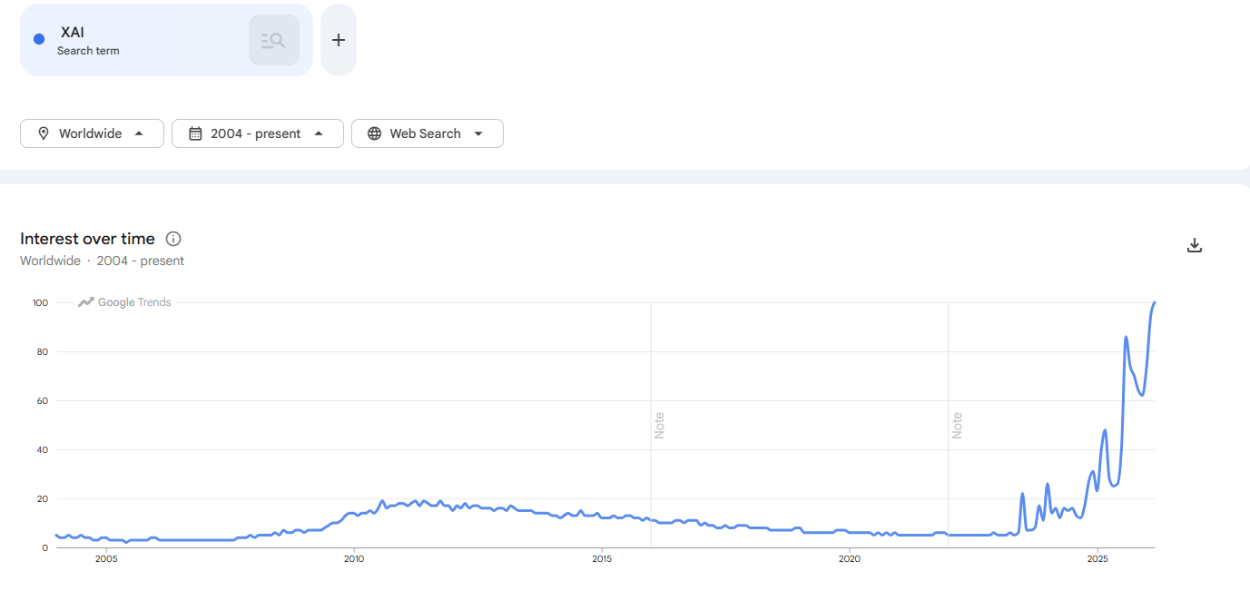
Graph 1: showing google trends search of the word XAI since 2004-2025

XAI term tends to refer to the movement, initiatives, and efforts made in response to AI transparency and trust concerns, more than to a formal technical concept. According to DARPA, a leading body in XAI research, XAI aims to ‘‘produce more explainable models, while maintaining a high level of learning performance (prediction accuracy); and enable human users to understand, appropriately, trust, and effectively manage the emerging generation of artificially intelligent partners’’(Adadi and Berrada, 2018). The goal of XAI is to ensure that the decision of AI models can be explained to end-users and other stakeholders in non-technical terms. The primary goal of this review is to investigate the recent applications of XAI with visual analytics across various domains. Fig 1 below shows the structural taxonomy of XAI research; there are several ways explainable AI can be categorized, and this image does a good job of highlighting them. XAI can be categorized on various metrics some of them are stage of explainability, Scope of explainability, Applicability, explanation mechanism (shown in Fig 2).
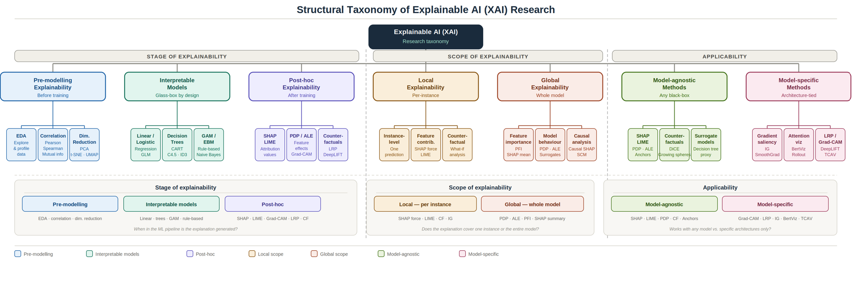
Fig 1: This diagram shows the structural taxonomy of explainable AI
Explainability and interpretability are used interchangeably. Interpretability is the ability to explain or provide the meaning of something in terms understandable to humans; the definition assumes implicitly that an explanation is self-contained and does not need further explanations(Andrienko, N. et al., 2022). As with machine learning models themselves, there is no universally best XAI approach; the optimal technique depends on factors such as the nature of the data, the specific application, and the characteristics of the underlying AI model(Saarela and Podgorelec, 2024).

Terminologies
Before we delve into this Review in depth, we need to learn a little more about machine learning, AI algorithms, and some terminologies used in the field.

Black-box models: AI or machine learning systems with opaque inner workings, the inputs and outputs are visible, but the internal decision-making logic is hidden or complex to understand.
Interpretability: The degree to which a human can understand the cause or prediction made by a machine learning model.
Explanation: Techniques and methods that reveal the reasoning behind an artificial intelligence system’s decisions making them understandable to humans
Gradients: their magnitude describes how a function f (.,.). Changes the values of a variable. It is often used to compute the contribution of each feature to the prediction by back propagating the gradient information from output to input(La Rosa et al., 2023).
Forward pass: the process of passing input through the neural network layer by layer, from the input layer to the output layer.
Backwards propagation: this is the fundamental algorithm for training neural networks, enabling them to learn by minimizing errors.
Loss function: a mathematical function that quantifies the inconsistency or error between the predicted output of a model and the actual output.
Perturbations: the idea of perturbation-based method is to modify the current input to probe the model’s behavior to test scenarios and extract insights(La Rosa et al., 2023)
Activations: They are the core element of DNNs, and several methods propose to analyze them to extract insights about their behavior(La Rosa et al., 2023)
Attention score: Dot product of the Query and Key produces the attention score
Attention weights: they are one of the latest tools used for explainability, and they can be combined with the structure of the models, often done in self-explainable DNNs(La Rosa et al., 2023).
Inference: This is the process of using a trained machine learning model to make real time predictions, decisions or generate new data.
Training: teaching computer models to recognize patterns and make predictions using large datasets, fundamental for machine learning and generative AI.
Data: data is the fundamental fuel for artificial intelligence, enabling models to learn patterns, make predictions, and generate outputs.
Evaluation: Objective assessment of a project, program, or policy’s merit. Worth, and significance.
Natural language processing: This is a subfield of computer science and artificial intelligence (AI) that focuses on the interaction between computers and human language.
Token: A unit of a text which the model reads
Vocabulary: list of unique tokens sorted in alphabetical order
Semantic Dependencies: The relationship between words in a sentence where the meaning of one word (the dependent) relies on or is determined by another word
Syntactic Dependencies: Word relations in a sentence are important features to understand the lexical makeup of a sentence

AI, Machine Learning, Deep Learning & LLMs
The field of Artificial intelligence, is a very broad field, containing many subsets, explainability can be added to these subsets to gain human understanding. It is important to know the subsets, as gaining a basic understanding on these concepts will help further our goal of an extensive review. Figure below shows the set diagram of Artificial Intelligence
A set diagram showing how these fields nest within each other
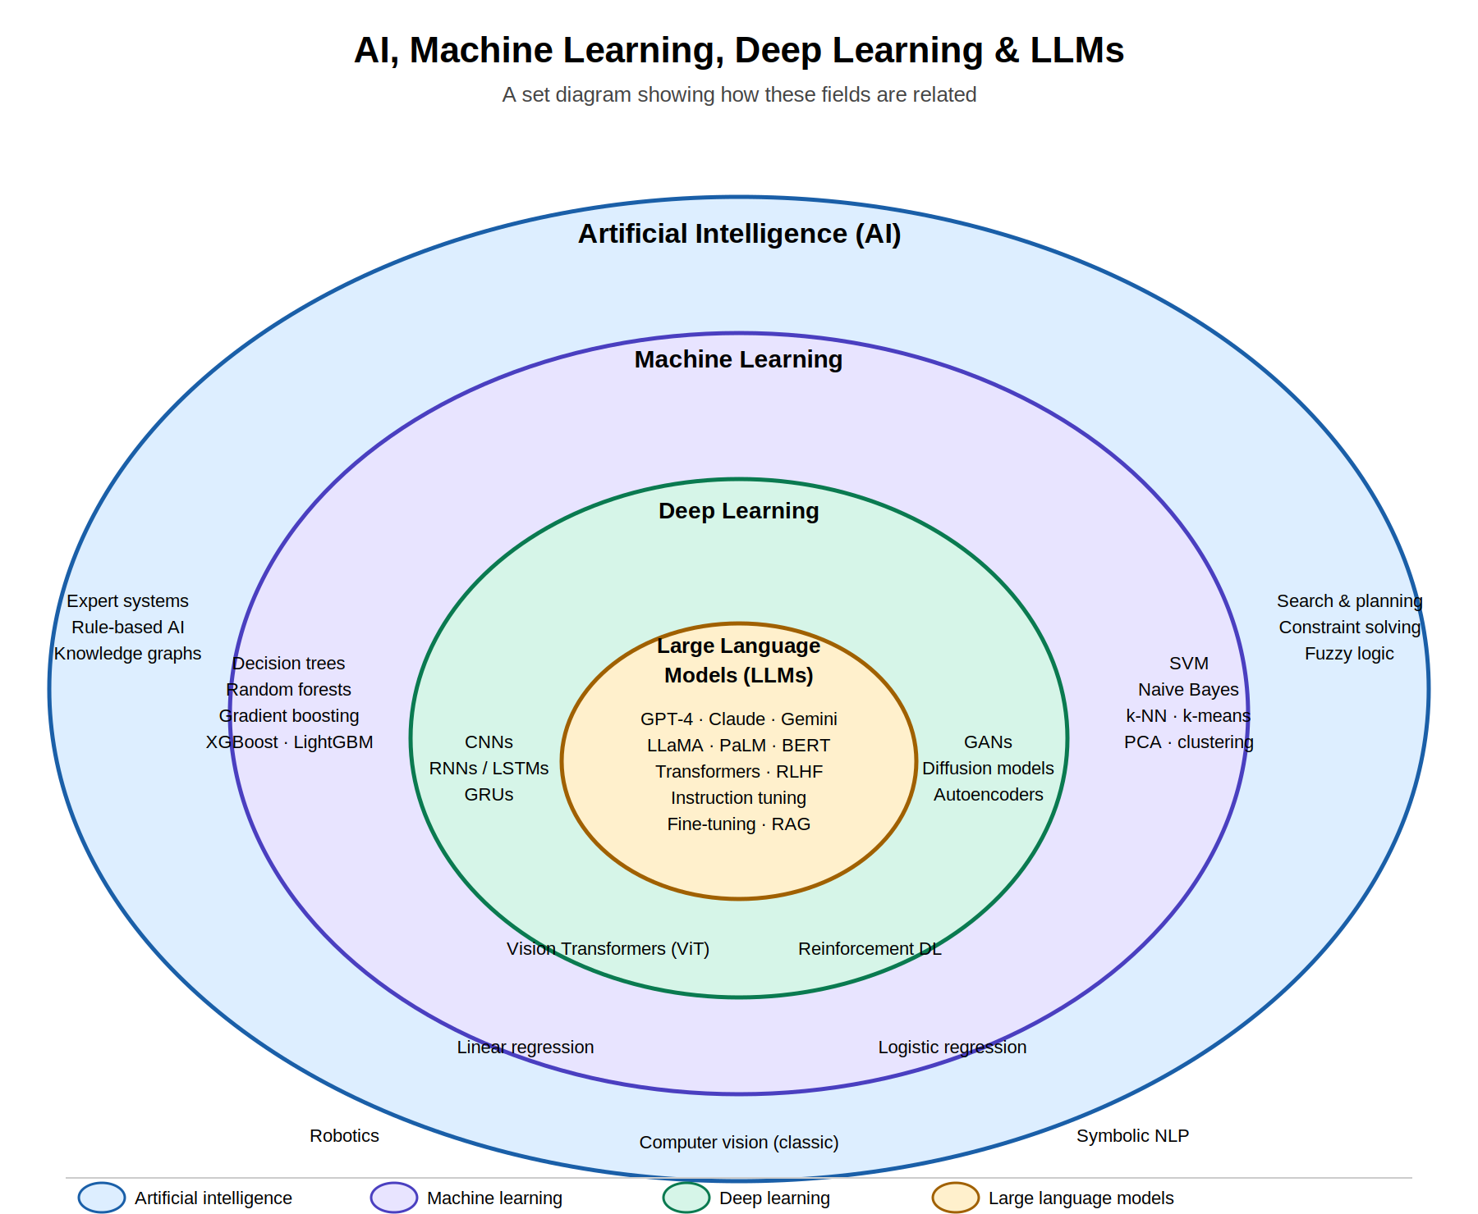
Figure: AI (outermost) ⊃ Machine Learning ⊃ Deep Learning ⊃ Large Language Models (innermost)

Machine learning
Machine learning can be divided into three categories: supervised learning, unsupervised learning, and reinforcement learning.
Supervised learning
Supervised learning is an ML model for investigating the input-output correlation
information of a system depending on a given set of training examples that are paired
between the inputs and the outputs. A labeled data set is used for training and testing, and the
output is predicted based on the algorithm. Examples of Supervised Learning are linear
regression, logistic regression, decision trees, random forests, K-nearest neighbor, and naive
Bayes (Badawy, 2023). Supervised ML models are used in situations when the outcome of
interest is specified, and data is explicitly labeled for the outcome (Alanazi, 2022).
Linear regression
Linear regression is one of the most used algorithms developed to predict a quantitative
variable using one or more independent variables with the assumption that the independent
variables and the outcome variables have a linear regression with each other (Alanazi, 2022).
Y = mX + c
where m indicates the slope and c indicates the intercept. The association between the
independent parameters (X) and the dependent parameters (Y) can be inferred. The Linear
regression drawback is it’s not convenient when applied to nonlinear relationships (Badawy,
2023).
logistic regression
This is a type of statistical model often used for classification and predictive analytics. Since The outcome is a probability; it’s bound between 0 and 1 (True and False). Like linear regression, logistic regression is also used to estimate the relationship between a dependent variable and one or more independent variables, but it is used to predict a categorical variable versus a continuous one (IBM, 2021). A disadvantage of logistic regression is that interactions must be added manually (Alanazi, 2022).
Decision trees Regression
Decision Tree Regression is a model used to predict a quantitative variable by asking several
questions in the form of true and false (Alanazi, 2022). A decision tree is simply a hierarchical representation of knowledge interactions that predicts when it is confident to make a correct prediction at the right time (Badawy, 2023).
K Nearest Neighbors
This simple prediction algorithm is known for its ease of implementation and interpretation
(Alanazi, 2022), KNN is used for solving classification problems. KNN determines the
distance of the nearest training data class labels with a new test data point in the existence of
a K value (Badawy, 2023).
Naïve Bayes classifier
Naive Bayes (NB) focuses on the probabilistic model of Bayes navies theorem and is simple to set up as the complex recursive parameter estimation is none, making it suitable for huge
datasets (Alanazi, 2022). NB is suitable for predicting outcomes with more than two levels,
where there are the assumption of independence and less training data is involved (Badawy,
2023). Some other advantages of NB are it can manage both continuous and discrete data,
and irrelevant features don’t affect the prediction. A major disadvantage of NB is that it
assumes that all features are independent which is not always the case in the real world.
Unsupervised Learning
Unsupervised learning follows the concept that a machine can learn to understand complex
processes and patterns on their own without interference from humans. This is the best
approach when is best when experts have no idea of what to look for in data. One of the
techniques used in unsupervised learning are clustering, here data are split into groups based
on similarity. The machine predicts the outcome based on past experiences and learns to
predict the real-valued outcome from the information previously provided (Badawy, 2023)

K-means
This is one of the most popular unsupervised learning algorithms that use clustering (Badawy,
2023). It classifies the dataset by a certain number of preselected clusters. Advantage of K
Clusters are that they are more computationally efficient than hierarchical grouping in case of large variables, as they provide more compact clusters. K means is also easy to implement and
comprehend. The disadvantages of k-means are the difficulty of predicting the value of k and
different starting sections leading to various final combinations, thus affecting performance
(Badawy, 2023).
Deep Learning: Deep Learning is a subset of machine learning that uses multilayered neural networks to simulate the complex decision-making power of the human brain. Deep learning varies from traditional machine learning because it uses several layers of neural network to train the model. Fig depicts the layers of a deep neural network, and the transformations take place within the model. The types of deep learning are convolutional neural networks (CNNs), Recurrent neural networks (RNN), Autoencoders and variational Autoencoders (VAEs), Generative Adversarial networks (GANs), Diffusion models, Transformer models. For the sake of conciseness of this review, we’ll be focused on only a portion of the types of deep learning
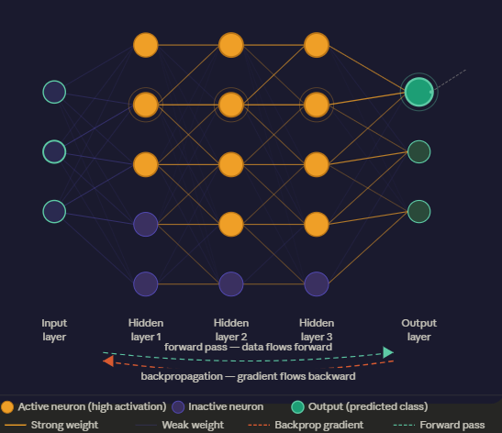
Fig :This image shows a deep neural network, all its layers and transformations
CNN: Convolutions, pooling and fully connected layers to analyze matrix-based data while exploiting spatial information. The convolutional layer’s output is called a feature map or activation map(La Rosa et al., 2023).
RNN: exploits the temporal information encoded in the data. Neurons process one step at a time, adding the results of the operations performed on the previous features additional input to the current one. Long Short-Term Memory Network (LSTM) is an example of these networks, this NN is mostly used for timeseries and textual data (La Rosa et al., 2023).
Transformers: These are composed of several layers employing attention mechanisms across neurons’ activation. Each layer contains several heads, specialized in capturing different aspects of the input through learned attention weights. self-attention mechanism, attention scores are calculated using weighted vectors Wq, Wk, and Wv as vectors for dot multiplication with input embedding, these produce the Query, Key and value vectors. Dot product of the Query and Key produces the attention score
Types of transformers and their architecture
- Encoder only (Good for classification problem, text classification, sentiment analysis, sequence tagging) e.g. BERT, DISTILBERT, BART
- Encoder-Decoder Transformer (Translation, summarization) e
- Decoder only (generates text, generating summary used in Gpt and Gemini)
What are Visual Analytics?
VA is the science of analytical reasoning supported by interactive visual interfaces(La Rosa et al., 2023). VA combines computer driven and human interactive components, to create understanding of complex models. With human input, we can steer VA systems to generate new visualizations and analyze data from a different perspective, which can lead to a better ability to investigate problems. Jeroen Ooge et al (2021) details several ways in which visual analytics can be interacted with, these are Abstract/elaborate, connect, Encode, Filter, Reconfigure, and select. Very often the challenge with applying AI and analytics in real-life scenarios is the level of complexity and information that is derived from the interfaces. In most cases, it would be wise to tailor the amount of interactivity involved during the visual analytics process so end users can be involved in the design process and easily identify their needs. This is known as human in the loop and builds trust for the system used. The interpretation from Most XAI models are mathematical representations, these are less intuitive for human understanding, presenting the findings as interactive visualizations, is the most intuitive way to get humans to understand the inner workings of these complex models. Fig 3 shows the visualization process. Visualization methods and techniques depends on the kind of represented data, such as text, numbers, multidimensional or hierarchical data, or networks (La Rosa et al., 2023).
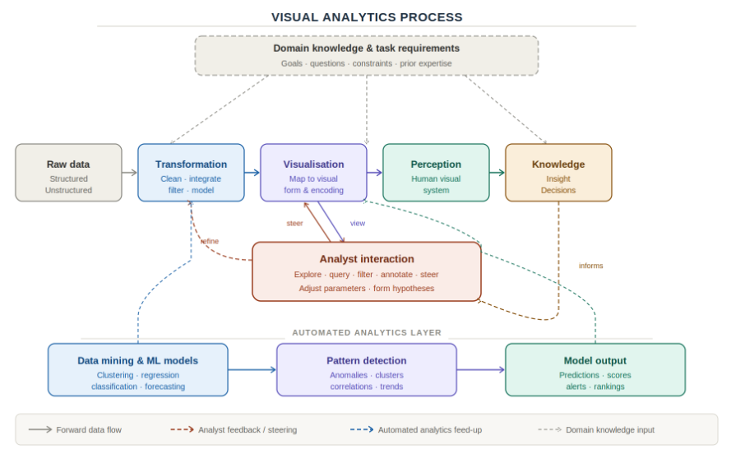
Fig 3: This diagram shows the flow of data, from raw data to model transformation, visualization and then human understanding

How XAI model visualizes their explanations
To understand AI, especially DNN and Transformer, there isa need to visualize its representation of hidden patterns. Researchers do this using different visualization techniques. In this review visualization of AI falls into five categories, all the papers looked at represented these categories differently, but for the most part it contains the same information. The explanation categories can be densely categorized into single groups of methods that share the same goals, this leads to merging some categories and splitting others. The Major categories used in this review are feature attribution, feature effect plots, saliency maps & heat maps, counterfactual & rule-based Fig displays these categories.
Feature attribution: These methods assign a score to each input feature based on its impact in determining the predicted outcome from the model(La Rosa et al., 2023). This explanation can be computed both at the Global or local level, using either post-hoc or intrinsic methods. Feature attribution answers the question of where the model is focusing on for computing predictions. This category is the most studied in literature. They include gradients-based methods, like Grad-CAM and Integrated Gradients. Also methods that back-propagate information from the last layers back to the inputs, like Layer Relevance Propagation (LRP) and Deconvolution Network (La Rosa et al., 2023). LRP redistributes prediction function backwards, starting from the output layer of the network and backpropagating up to the input layer. The key property of this redistribution process is referred to as relevance conservation(Adadi and Berrada, 2018).
LIME method is the most popular model-agnostic XAI method often adopted in vXAI (Alicioglu and Sun, 2022). LIME method is often used in various data domains such as tabular, image, and text due to its easy-to-use feature. Several vXAI works, such as ExplainExplore, SUBPLEX, and DeepVID, modified and integrated the LIME method into their interactive VA platforms to explain NN models locally(Alicioglu and Sun, 2022). SHAP is the other popular feature-based XAI method used for feature explanation(Alicioglu and Sun, 2022).

Feature Effects Plots: This method plots each input feature against the predicted outcome from the model, this creates a trend, where features effect on the output prediction can be seen. Variable importance quantifies the contribution of each input variable (feature) to the predictions of a complex ML model(Adadi and Berrada, 2018). Partial dependency plot and Individual conditional expectation (ICE) are examples of feature effects plots. PDP is a graphical representation that helps visualize the average partial relationship between one or more input variables and the predictions of a black-box model(Adadi and Berrada, 2018). Goldstein et al introduced ICE techniques and proved it advantage over PDP. ICE plots extend PDP, whereas PD plots provide a coarse view of a model’s workings, ICE plots reveal interactions and individual differences by disaggregating the PDP output. Recent works use ICE rather than classical PDP (Adadi and Berrada, 2018).

Saliency and heatmaps: Saliency maps are often used to highlight the contributions of features for each sample through propagation. Li et al. used saliency maps to explain contributions and negations of words to the predictions obtained by LSTMs. CAM and Grad-CAM methods are proposed to improve the saliency. Kim et al. utilized CAM method to obtain salience values for text classification. Saliency values are visualized using gray-scale saliency maps to explain CNNs (Alicioglu and Sun, 2022). Heatmaps are used for image input, it highlights the portion of the image most relevant to the prediction made

Counterfactuals: Wachter et al. presented the concept of ‘‘unconditional counterfactual explanations’’ as a novel type of explanation of automated decisions. Counterfactual explanations describe the minimum conditions that would have led to an alternative decision (Adadi and Berrada, 2018). In other words, counterfactuals are samples as similar as possible to the current input but associated with a different prediction. They answer the question ‘What do I have to change to obtain a different outcome’ and they are beneficial for recourse(La Rosa et al., 2023)

rule based: Rule-based explanations are another often seen XAI method used in vXAI study. The method provides logical statements, i.e., IF...THEN...ELSE, to present rule lists that explain the predictions (Alicioglu and Sun, 2022). The survey by Ras had taken on the classification of rule extraction strategies proposed earlier in and proposed three modes to extract rules (Adadi and Berrada, 2018): (a) pedagogical rule extraction, (b) decompositional rule extraction and (c) eclectic Rule-Extraction.
Decompositional approaches focus on extracting rules at the level of individual units within the trained ANN. While pedagogical approaches treat the trained ANN as a black-box i.e. the view of the underlying ANN is opaque, the Orthogonal Search-based Rule Extraction algorithm (OSRE) from is a successful pedagogical methodology often applied in biomedicine. The third type (eclectic) is a hybrid approach for rule extraction that incorporates elements of both the decompositional and pedagogical rule-extraction techniques (Adadi and Berrada, 2018)

Representation and concept visualization: Several approaches can be used for this type of visualization, some of the methods are surrogate model, and example based. A surrogate model is a simple model used to explain a com plex model. More specifically, it is an interpretable model (like a linear model or decision tree) which is trained on the predictions of the original black-box model to interpret the latter (Adadi and Berrada, 2018). Example-based explanation techniques select instances of the dataset to explain the behavior of machine learning models. Example-based explanations are mostly model-agnostic because they make any ML model more interpretable(Adadi and Berrada, 2018). Example based method answers the question ‘Which samples are considered similar by the model’ by showing samples on which the model acts similarly (La Rosa et al., 2023). These methods are usually search-based and differ in the way in which they define the similarity (e.g. at the input, latent space or feature attributions level) and are usually based on enhanced versions of the K-nearest neighbor algorithm (La Rosa et al., 2023).
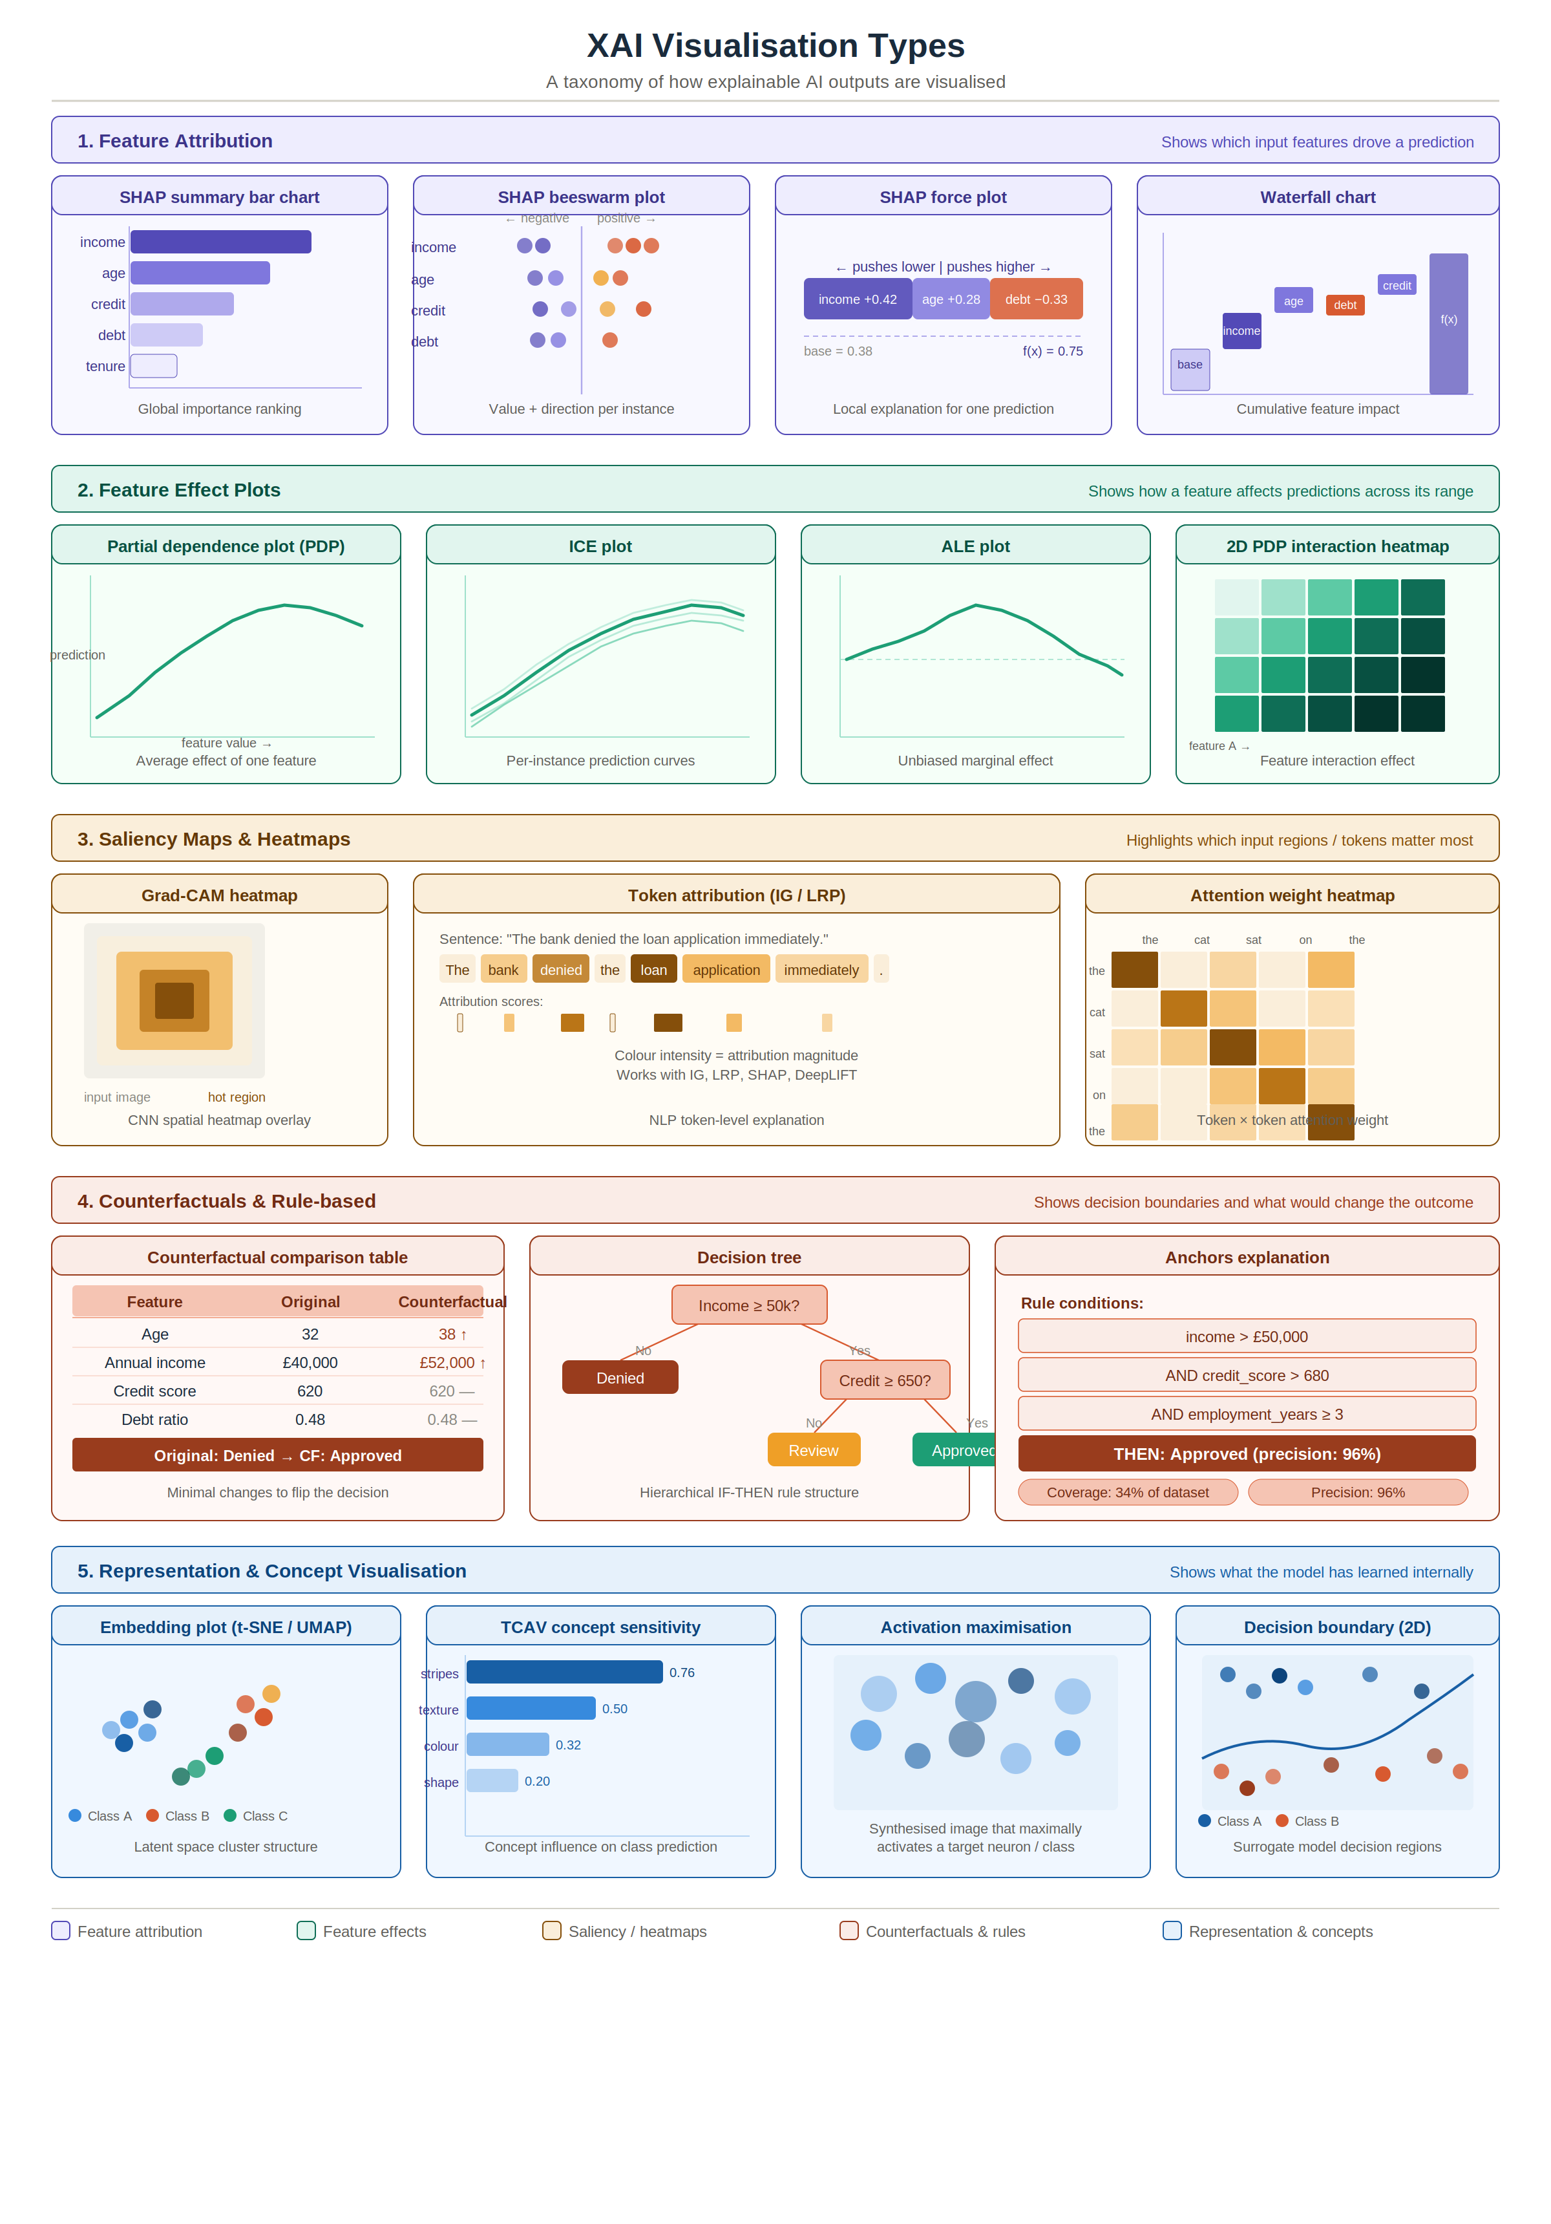

What is XAI?
Explainable Artificial Intelligence(XAI) is a new research field that aims to provide understandable artificial intelligence(AI) results for end-users(Alicioglu and Sun, 2022). Most machine learning, and deep learning models are “black box”, this simply means the inner workings of these models are unknown, the goal of XAI is the make these models white box, thereby providing understandable, trustworthy, and explainable rationales for decisions made by the black box models. While some studies mathematically define explainability, other studies emphasize that explainability should include more non-technical concepts to increase human-understandability(Alicioglu and Sun, 2022). The XAI methods can be divided into three main categories based on explanation level, implementation level, and model dependency. The subcategories of the explanation level of an XAI method are named global level, which focuses on the explainability of the entire model, and its working and decision-making mechanisms, and local level, which explains the decisions of a model for a single instance or subpopulation.
A very important aspect of this research and the progression of Visual analytics in the explainability of AI is its ability to take human input and interaction. Fig 2 shows how XAI opens a black box making it more explainable. XAI can also be categorized based on the stage that the method is applied, the stages are pre-modelling (EDA), Interpretable model (intrinsic model), post-modelling (post-hoc explainability). The final categorization of XAI is on the restriction of use of a method, some methods are restricted to a particular model, they are model specific. While others can be used for several models, they are model agnostic. Fig 1 shows detailed categorization of XAI.

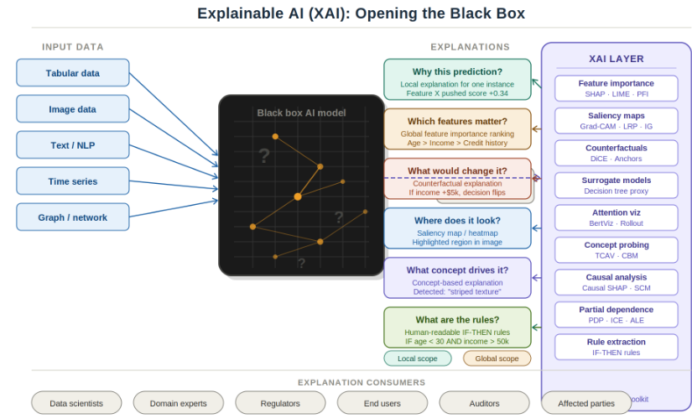
Fig 2: showing how XAI takes advantage of black box models, to understand the inner workings of the model and make them white box
Types of Explainability
Global Explainability methods
This describes the model’s behavior on a wider range of inputs or datasets, capturing and extracting common patterns B. La Rosa et. Al (2023). In Milot Gashi et. Al’s research, several Python libraries were identified, these libraries focused on methods for global explainability, and visualization techniques used to communicate the explainability results. The libraries identified are ELI5, Dalex, InterpretML, and SHAP. As stated earlier, the models are being looked at in B. La Rosa et. Al (2023) is quite limited, there are more complex models using several techniques to create globally explainable systems, these systems are listed in Table 1.
Table 1: showing all techniques that can be used to obtain a Globally explainable model, if its machine learning based or not, Data types, Key output produced
Local Explainability Methods
Local explainability methods give insight into the decision of a model made on a specific input sample B. La Rosa et. Al (2023). Global explainability seeks to uncover the reasons for the predictions made by the Blackbox algorithm. Local explainability focuses on gaining the User’s trust for individual predictions and then trusting the model as a whole Milot Gashi et. Al’s, 2022. Milot Gashi et. Al’s research focused on two Python libraries to explain this, the libraries are SHAP and LIME. Milot Gashi et. Al’s research is quite limited as it focuses on only on limited amount of python libraries, other methodologies exist, and some machine learning techniques are now being used to further explain these black box models, table 2 contains a comprehensive list of models that makes use of local explainability.

Why is XAI Important?
In today’s landscape AI is being integrated at every level of society due to its efficiency at performing tasks, while producing accurate results. However decades have been spent producing these predictive algorithms, and we’ve neglected the ethical aspect of the field. A surgeon can be held accountable for a botched operation, however with AI there are no accountability measures, as we are the sole people responsible for our own decisions and actions, AI is yet to be seen as a responsible entity. Research is now being done in the field to hold AI accountable, A movement to show the inner workings of AI systems and understand the logic of their predictions in a manner intuitive to humans is called XAI. Therefore, there is an increasing demand for a new generation of XAI technology to completely understand how AI models make predictions. The explanation of the decision-making process in AI systems is particularly critical for various industries, such as financial, healthcare, and security (Minh et al., 2022).
The lack of the ability to explain the logical reason why some ML algorithms have reached human-level performance is rooted in two primary problems. The first problem is the huge differences between the research community and the business sectors that prevent a complete integration or replacement of the newest ML systems into the rigorously controlled industries, because the new technologies can put existing systems at risk if the users do not fully understand them. The second issue is the uncertainty regarding the AI’s performance (Minh et al., 2022). In other for AI systems to be human understandable to the extent that we can rely on them, there are certain boxes that need to be ticked, these include Improved transparency, Improved trust, and Improved Model Bias understanding and fairness. According to Adadi and Berrada (2018) there are four motivations for explaining AI, They are
Explain to Justify: When we talk about an explanation for a decision, we generally mean the need for reasons or justifications for that particular outcome, rather than a description of the inner workings or the logic of reasoning behind the decision-making process in general. This ensures that there is an auditable and provable way to defend algorithmic decisions as being fair and ethical, which leads to building trust.
Explain to control: Understand more about a system, provides greater knowledge of the system’s flaws and vulnerabilities. This helps to find errors in critical situations and is very useful for debugging the system hence giving a sense of control
Explain to improve: There is a need to continuously improve the AI models. A system that we fully understand is a system that can easily be improved, as all resources and time will be directed towards addressing the current system’s flaws.
Explain to Discover: XAI has helped discover new knowledge in various fields, as we know AI now excels more than humans at certain tasks, so with an understanding of these systems, we can gain knowledge on how to perform these tasks more effectively.

How is XAI Implemented?
XAI has been classified in so many ways, of all the ways it’s been categorized, Minh et al 's (2022) categorization makes the most sense. describes a systematic categorization for all the existing XAI approaches which include the pre-modeling explainability, the interpretable model, and the post-modeling explainability(Minh et al., 2022). Further explanations on these categories will be handled in this section; it is however important to note that the categories of explainability are directly related to the level which explainability
- Understanding the data itself (pre-modeling explainability)
- Understanding the whole system from input to output, due to model being white box (interpretable model/intrinsic explainability)
- Understanding the system from the output produced (Post modelling explainability/ post-hoc)
Pre-modeling explainability
Pre-modeling explainability refers to a series of data processing approaches, which is implemented to gain an insight into the datasets collected to train the ML models(Minh et al., 2022).
Data analysis
Data analysis often referred to as exploratory data analysis is the process of extracting, transforming, loading, and modeling data in order to identify crucial features required for an AI model to make it decisions (Minh et al., 2022). There are four types of data analysis, the classification is based on what the data is to be used for.
Types of Data analysis
Descriptive analysis
Descriptive analysis describes, shows, or summarizes raw data points to provide insightful information about the data. This is often past data that data scientist analyzes to understand how they impact feature behaviors(Minh et al., 2022).
Predictive analysis
Predictive analysis is the model’s ability to predict future outcomes based on probabilities. Predictive analysis enables analysts to know the likelihood of an event occurring(Minh et al., 2022).
Diagnostic analysis
Diagnostic analysis involves many methods, such as data discovery, drill-down, correlations, and data mining, to describe why events occur. This type of analysis is useful for detecting anomalies and relationships(Minh et al., 2022).
Prescriptive analysis
Prescriptive analysis allows users to decide on possible action to take based on outputs from the algorithms. This type of analysis consists of both descriptive and predictive analysis, it exceeds them by offering various methods, such as algorithms, and business rules on various types of datasets(Minh et al., 2022).
Data summarization
Data summarization is the process of creating a detailed report of the initial data, whether it is structured or unstructured. Summarization is dependent on how the data is stored, for structured data, we summarize in spreadsheets and relational databases, while we summarize unstructured data as text summarization(Minh et al., 2022).
Data transformation
The data transformation is a basic rule-based data processing method that is applied to map the structure of the source datasets into a target structural format(Minh et al., 2022).
Correlation Analysis (Pearson/Spearman)
Correlation analysis is a statistical technique used to measure the strength and direction of the relationship between two or more variables.
Pearson correlation: The Pearson correlation coefficient is a descriptive statistic, meaning that it summarizes the characteristics of a dataset. Specifically, it describes the strength and direction of the linear relationship between two quantitative variables.
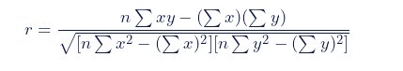
Spearman: It’s a rank correlation coefficient because it uses the rankings of data from each variable (e.g., from lowest to highest) rather than the raw data itself.
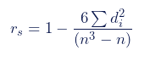
.
Dimensionality reduction: Dimensionality reduction techniques transform dataset X with dimensionality D into a new dataset Y with dimensionality d, while retaining the geometry of the data as much as possible. Dimensional reduction algorithms tend to fall into two categories; those that seek to preserve the pairwise distance structure amongst all the data samples and those that favor the preservation of local distances over global distances. Algorithms such as PCA MDS, and Sammon mapping fall into the former category while t-SNE, Isomap, LargeVis, Laplacian eigenmaps and diffusion maps all fall into the latter category(McInnes et al., 2020).
Principal Component Analysis (PCA): Principal component analysis (PCA) is a multivariate technique that analyzes a data table in which observations are described by several inter-correlated quantitative dependent variables. Its goal is to extract important information from the table, to represent it as a set of new orthogonal variables called principal components, and to display the pattern of similarity between the observations and of the variables as points in maps(Abdi and Williams, 2010)
UMAP: UMAP uses local manifold approximations and patches together their local fuzzy simplicial set representations to construct a topo logical representation of the high dimensional data. Given some low dimensional representation of the data, a similar process can be used to construct an equivalent topological representation. UMAP then optimizes the layout of the data representation in the low dimensional space, to minimize the cross-entropy between the two topological representations(McInnes et al., 2020).
Use PCA when:
  - You need a fast, simple, and interpretable baseline.
  - You are doing initial EDA and want to understand the main axes of variation.
  - You are pre-processing data for a linear model (like linear regression) and want to reduce collinearity.
  - The relationships in your data are suspected to be primarily linear.
Use UMAP when:
  - Your primary goal is high-quality, intuitive 2D/3D visualization of complex data.
  - You suspect your data has clusters, loops, or other non-linear structures that PCA cannot reveal.
  - You are working with very high-dimensional data like biology (genomics, single-cell data) or NLP (word vectors).

Interpretable model (Intrinsic explanations)
Model intrinsic explainable methods have interpretable elements built into them. Due to the use of AI in high stakes fields, where human lives and resources could be lost, fields such as public health, finance and criminal justice. It is important that these black box models are made transparent. Creating algorithms to solve this black box models, instead of making inherently explainable models is bad practice, which can be dangerous to society. Inherently interpretable models can be divided into three levels of explainability, these are simulatability, decomposability, and algorithmic transparency.
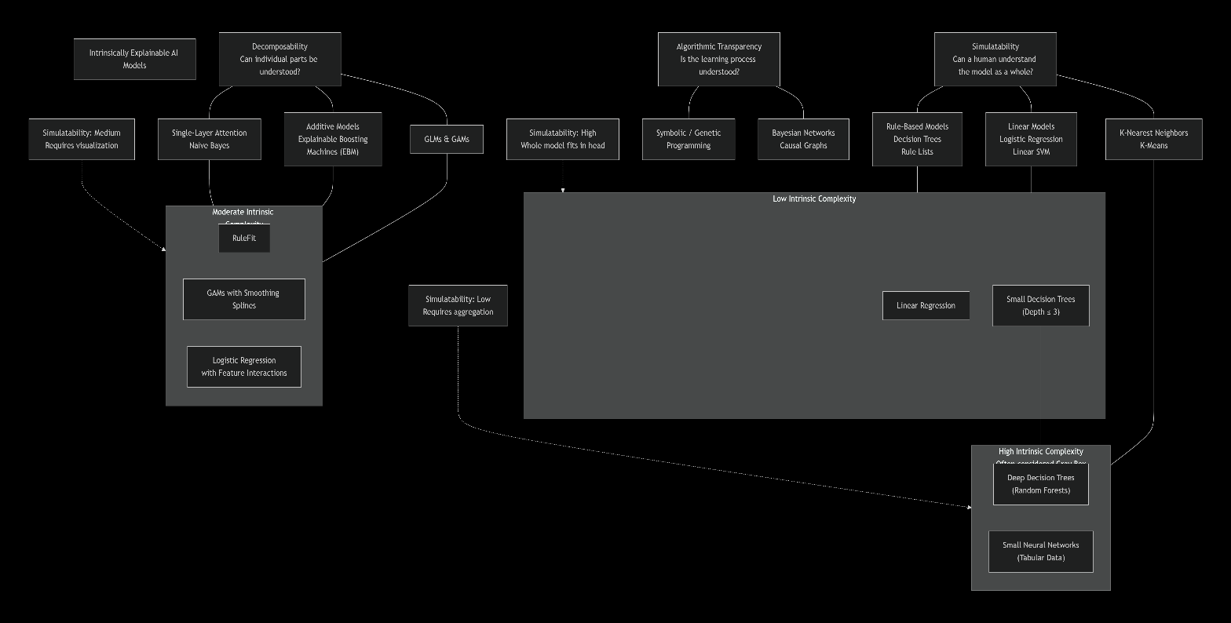

Post-Modeling explainability (post-hoc explanations)
If a model does not meet the criteria for it to be considered interpretable, we’d have to treat it as a black box model, as we have no knowledge of internal operations and model architecture. Post hoc explanation methodology is extremely useful as existing accurate models can benefit from added interpretability (Das and Rad, 2020). Post-hoc explanations can be done for either a pre-trained model or when the training process of a model is complete (Alicioglu and Sun, 2022). There are two classifications for Post modeling explainability, these are Model-specific approaches which were proposed for a particular AI models and Model-agnostic approaches which were developed to be used with any AI algorithm.
Model-specific approach
This includes a set of techniques that were proposed to improve the explainability of a particular black-box AI model. analysis of recent literature related to the model-specific post-modeling explainability, various trending topics emerged. Firstly, the rule-based extraction method predominates this topic (Minh et al., 2022). The drawback of this practice is that when we require a particular type of interpretation, we are limited in terms of choice to models that provide it (Adadi and Berrada, 2018), and they cannot be used for any model without re-changing its explanation mechanism (Alicioglu and Sun, 2022)
Model-agnostic approach for the post-modeling explainability
This type of approach is not tied to a particular type of model, Model-agnostic interpretations are usually post-hoc, they are generally used to interpret ANN and could be local or global interpretable models(Adadi and Berrada, 2018). These methods are often used due to their flexibility; they separate predictions from explanations. ANCHORS, LIME, LRP, SHAP are the most popular examples of model agnostic post-hoc methods (Alicioglu and Sun, 2022)
Explainable LLM visualization tools
Large language models LLM are still a very new area in the application of AI models, they consist of millions to trillions of parameters and operate on sequence models, generating, summarizing, translating and reasoning over text. The building block of LLMs are transformers, so to understand a LLM, we’ll need to understand transformers. As LLMs become increasingly powerful and useful for day-to-day tasks, it is important to know the innerworkings of how tasks are performed and decisions are made. Due to the complexity of transformers, we’d often need to use a combination of methods to gain insight. Over the last five years, here are some tools that have been developed to gain an understanding of transformers.
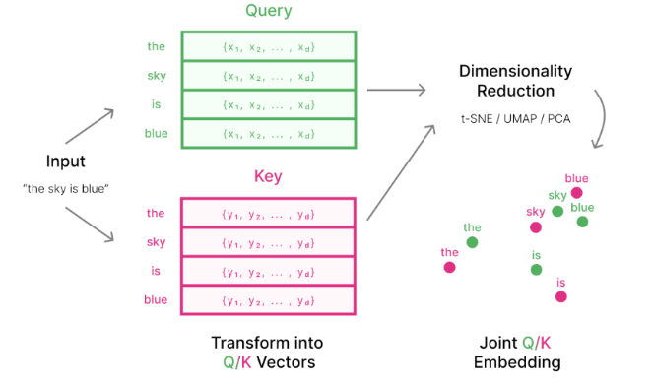
Attention Viz: This is a tool that was designed to visualize the self-attention mechanism at each head, layer of a transformer, and offer deeper insight up to the image or sentence level of a particular token (Yeh et al., 2023). The self-attention mechanism of transformers; this is the most revolutionary discovery in transformers as it allows transformers to learn and use the rich set of relationships between input elements. The primary technique of this research is visualizing joint embedding of the query and key vectors used by transformers. The tool provides several options for visualizing; there is provision for both global and local level explainability. An effective method to visualize multiple inputs is to visualize a collection of embedded vectors from multiple input sequences, Each attention transformer head turns input embedding into query vectors and key vectors by applying matrices $W_{Q} and W_{K} ADDIN ZOTERO_ITEM CSL_CITATION \{"citationID":"aM3x1tqs","properties":\{"unsorted":false,"formattedCitation":"(Yeh et al., 2023)","plainCitation":"(Yeh et al., 2023)","noteIndex":0\},"citationItems":[\{"id":202,"uris":["http://zotero.org/users/19902890/items/8XGK3AC2"],"itemData":\{"id":202,"type":"article-journal","container-title":"IEEE Transactions on Visualization and Computer Graphics","DOI":"10.1109/TVCG.2023.3327163","ISSN":"1077-2626, 1941-0506, 2160-9306","journalAbbreviation":"IEEE Trans. Visual. Comput. Graphics","language":"en","license":"https://ieeexplore.ieee.org/Xplorehelp/downloads/license-information/IEEE.html","page":"1-11","source":"DOI.org (Crossref)","title":"AttentionViz: A Global View of Transformer Attention","title-short":"AttentionViz","author":[\{"family":"Yeh","given":"Catherine"\},\{"family":"Chen","given":"Yida"\},\{"family":"Wu","given":"Aoyu"\},\{"family":"Chen","given":"Cynthia"\},\{"family":"Viégas","given":"Fernanda"\},\{"family":"Wattenberg","given":"Martin"\}],"issued":\{"date-parts":[["2023"]]\}\}\}],"schema":"https://github.com/citation-style-language/schema/raw/master/csl-citation.json"\} (Yeh et al., 2023)$. These matrices then project the vector embedding to a lower dimensional space, getting only specific information from the higher-dimensional vector embedding, this is achieved by using dimensionality reduction techniques. We obtain the key and query vector representation of each token in each sentence, then use dimensionality reduction techniques such as t-SNE, UMAP or PCA to project the high-dimensional vector into low-dimensional space (Yeh et al., 2023).


(Yeh et al., 2023)
Vector normalization is applied prior to dimensionality reduction; this is to tune the ‘free parameters’ and create a closer relationship between embedding distance and attention weights (SoftMax function).
Attentionj(x) = softmax j((x,y1),(x,y2),….)
= softmax j((x,y1)+(x,v),(x,y2)+(x,v),….)
= softmax j((x,y1+v),(x,y2+v),….)
This attention VIZ is used for language and vision transformers, it was implemented on BERT, GPT, and VIT .
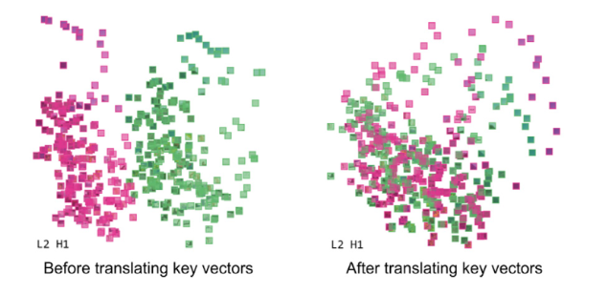
(Yeh et al., 2023)
It's important to note that each dimensionality reduction technique will produce different patterns. This research framework provides three interactive views, Matrix view, single view, and sentence/Image view.

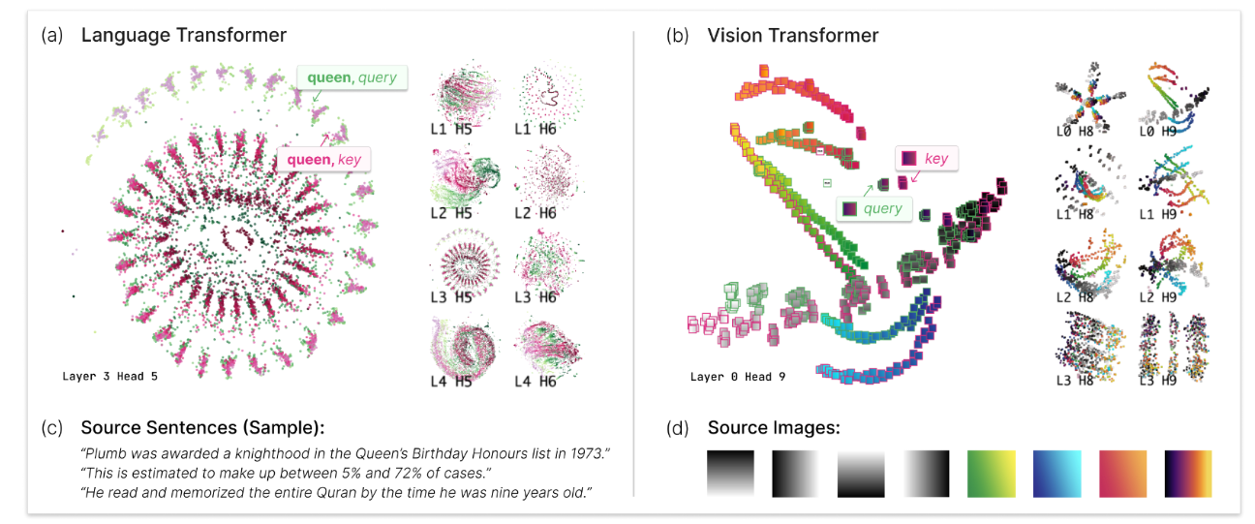
(Yeh et al., 2023)

The key findings from this research are:
- plots with spirals and clump tokens encode positional patterns; token position increases as we move from the outside to the inside of the spiral.
- The difference between spirals and clumps appears to be whether token attends selectively to others one position away, vs several different positions
- Heads with high query-key overlap. Tokens typically attend to themselves and other instances of the same token
- Earlier layers have more have the most information about linear word order
- Mid-to-later model layers contain syntactic and task-specific information; for instance, later layers have query-key sandwich, where keys and queries at the beginning of text are stacked, followed by being in reverse order at the end of the text.
VisBERT: This tool proposed a layer-wise visualization of token representations that reveals information about the internal state of Transformer networks, more specifically focused on BERT and its performance on three question and answer tasks; Babi, SQuaD, and HotpotQA. It was, however, used on GPT at later stages of development in comparison with the results of BERT (Aken et al., 2020). This research made use of dimensionality reduction techniques, K-means clustering, and principle of edge probing.
Dimensionality reduction: BERT’s pretrained models use vector dimensions of 1024 (BERT-large) and 512 (BERT-base), this technique is used to visualize relations between tokens (Aken et al., 2020).
K-means Clustering: To verify that clusters in 2D space represent the actual distribution in high dimensional vector space, we apply k-means clustering (Aken et al., 2020).
principle of Edge probing: this translates core NLP tasks into classification tasks by focusing solely on their labeling part (Aken et al., 2020).
The research adopts the tasks Named Entity Labeling, Conference Resolution, Relation classification and adds question type classification and supporting fact identification due to their importance for question answering (Aken et al., 2020).
Results of the research
Semantic Clustering: Early layers within BERT-based models group tokens into topical clusters. This clustering still holds little task-specific information (Aken et al., 2020).
Connecting Entities with Mentions and Attributes: In the middle layer, clustering is less connected by their topical similarities. Tokens are connected by their relation to certain input contexts (Aken et al., 2020).
Matching Questions with Supporting Facts: Identifying relevant parts of the context is crucial for QA and information retrieval. BERT performs this task by transforming the tokens so that question tokens are matched onto relevant tokens (Aken et al., 2020).
Answer Extraction: In the last network layers, the model dissolves most of the previous clusters. It then separates the correct answer token, and sometimes other possible candidates, from the rest of the tokens (Aken et al., 2020).

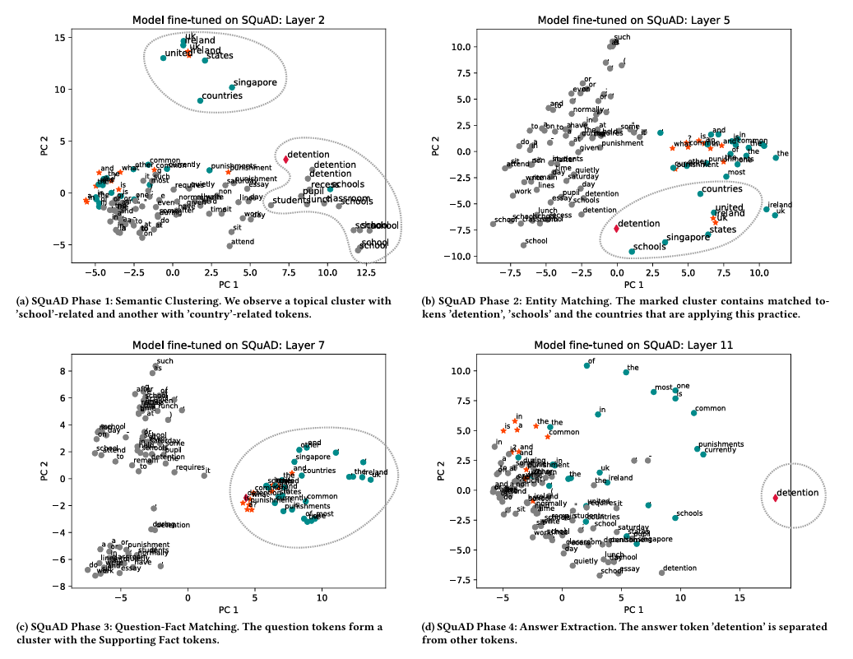
(Aken et al., 2020)
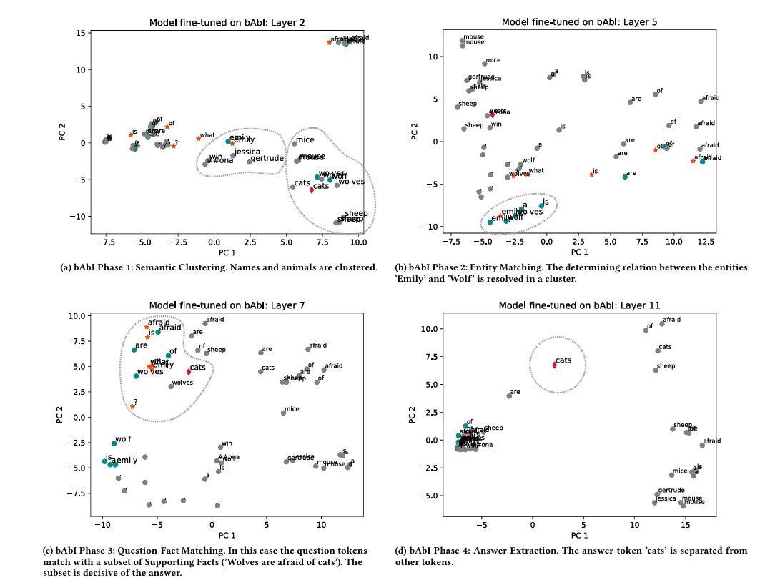
(Aken et al., 2020)
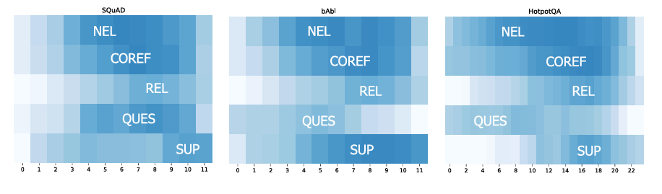
(Aken et al., 2020)
BERTVIZ: This was one of the initial tools designed to visualize attention, it provides three views used for GPT and BERT attention visualization. These views are attention-head view, model view, and neuron view (Vig, 2019)
Attention head view
Visualizes the attention patterns produced by one or more attention heads in each layer. attention is represented as lines connecting the tokens that are attending with the tokens being attended to (Vig, 2019) . Besides positional patterns, attention heads also capture specific lexical patterns other attention heads detected named entities, paired punctuation, subject-verb pairs, other syntactic and semantic relations (Vig, 2019). Use case for attention-head view, is the detection of bias in the model. The two examples are shown in figure 4 (right), which reveals she attended strongly to nurse, while he attends more to doctor. This shows the models’ coreference mechanism may encode gender bias (Vig, 2019).
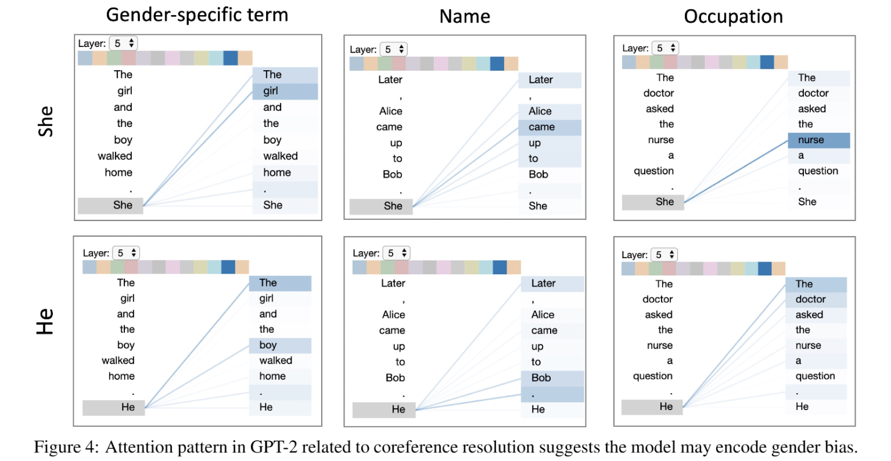
(Vig, 2019)
Model view
The model view provides birds eye view of attention across all the model’s layers and heads for a particular input. Users can also click on any head to enlarge tokens, and access attention head view(Vig, 2019).
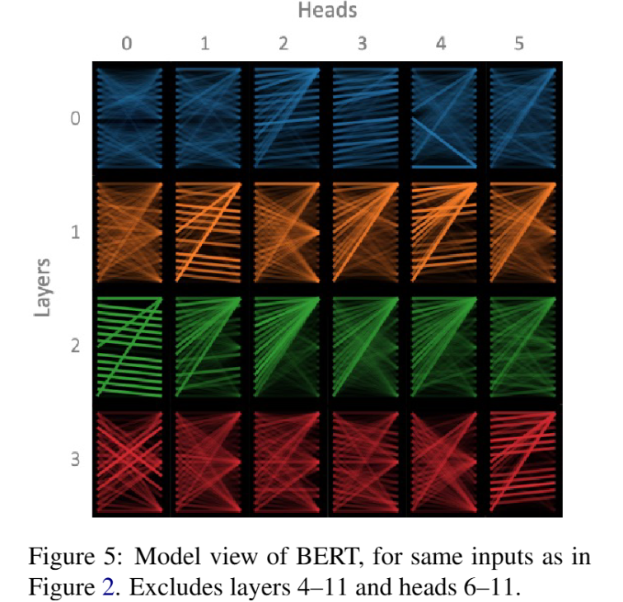
(Vig, 2019)
Neuron view
visualizes the individual neurons in the query and key vectors and shows how they interact to produce attention. This view shows that the attention decays with increasing distance from the source token (Vig, 2019). A small number of neuron positions appear to be mostly responsible for the distance decaying attention pattern, at these neuron positions, the element-wise product q x k decreases as the distance from source token decreases (either becoming darker orange or lighter blue) (Vig, 2019).

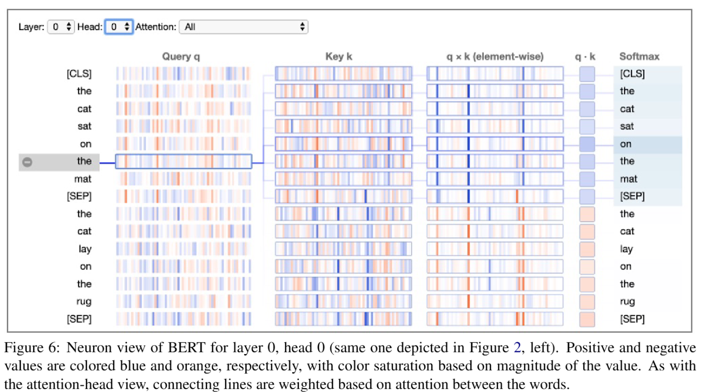
(Vig, 2019)
Transformer Vis: This tool makes use of a technique called “Probing task” to interpret a transformer. This is done by attaching a light-weight auxiliary classifier at the output of the target transformer layer. The auxiliary classifier is then trained on well-known NLP tasks like part-of-speech (POS) tagging, Named-entity recognition (NER) Tagging, syntactic Dependency (Yun et al., 2021). There are, however, limitations to probing tasks:
- POS and NER are too simple.
- Probing tasks can only verify whether a certain prior structure is learned in a language model.
- It’s hard to locate where exactly the related linguistic representation is learned in the transformer.
The paper hypothesizes that contextualized word embedding as a sparse linear superposition of transformer factors x ∈ X (Yun et al., 2021).

We compute an importance score for each transformer factor to understand where the network learns certain information. The transformer factor I_{c}, where I_{c} is the average of the largest 1000 sparse coefficients αc, which corresponds to $X_{c} ADDIN ZOTERO_ITEM CSL_CITATION \{"citationID":"mzpQEpVx","properties":\{"unsorted":false,"formattedCitation":"(Yun et al., 2021)","plainCitation":"(Yun et al., 2021)","noteIndex":0\},"citationItems":[\{"id":180,"uris":["http://zotero.org/users/19902890/items/JE84WEAG"],"itemData":\{"id":180,"type":"paper-conference","abstract":"Transformer networks have revolutionized NLP representation learning since they were introduced. Though a great effort has been made to explain the representation in transformers, it is widely recognized that our understanding is not sufﬁcient. One important reason is that there lack enough visualization tools for detailed analysis. In this paper, we propose to use dictionary learning to open up these ‘black boxes’ as linear superpositions of transformer factors. Through visualization, we demonstrate the hierarchical semantic structures captured by the transformer factors, e.g., word-level polysemy disambiguation, sentence-level pattern formation, and long-range dependency. While some of these patterns conﬁrm the conventional prior linguistic knowledge, the rest are relatively unexpected, which may provide new insights. We hope this visualization tool can bring further knowledge and a better understanding of how transformer networks work. The code is available at https://github. com/zeyuyun1/TransformerVis.","container-title":"Proceedings of Deep Learning Inside Out (DeeLIO): The 2nd Workshop on Knowledge Extraction and Integration for Deep Learning Architectures","DOI":"10.18653/v1/2021.deelio-1.1","event-title":"Proceedings of Deep Learning Inside Out (DeeLIO): The 2nd Workshop on Knowledge Extraction and Integration for Deep Learning Architectures","language":"en","page":"1-10","publisher":"Association for Computational Linguistics","publisher-place":"Online","source":"DOI.org (Crossref)","title":"Transformer visualization via dictionary learning: contextualized embedding as a linear superposition of transformer factors","title-short":"Transformer visualization via dictionary learning","URL":"https://www.aclweb.org/anthology/2021.deelio-1.1","author":[\{"family":"Yun","given":"Zeyu"\},\{"family":"Chen","given":"Yubei"\},\{"family":"Olshausen","given":"Bruno"\},\{"family":"LeCun","given":"Yann"\}],"accessed":\{"date-parts":[["2026",3,19]]\},"issued":\{"date-parts":[["2021"]]\}\}\}],"schema":"https://github.com/citation-style-language/schema/raw/master/csl-citation.json"\} (Yun et al., 2021)$. We plot the importance score each transformer factor as a curve
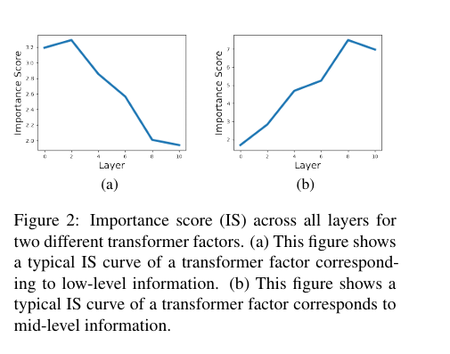
(Yun et al., 2021)
This research used a 12-layer pre-trained BERT model and freeze the weights. Since we learn a single dictionary of transformer factors for all the layers in the transformer, Yun et al (2021) proposed that these transformer factors correspond to different levels of semantic or syntactic patterns. What happens at these different levels of transformer factors are word-level disambiguation, sentence-level pattern formation, and long-range dependency (Yun et al., 2021). transformer factors with early IS curve peaks usually correspond to a specific word-level meaning. By visualizing the top activation sequences, we see how word-level disambiguation is gradually developed in a transformer (Yun et al., 2021).
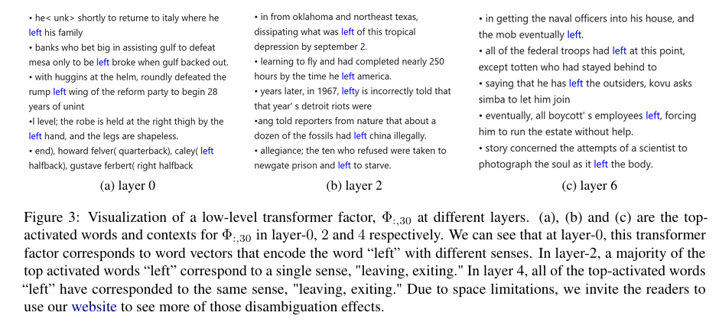
(Yun et al., 2021)
Midlevel ones correspond to semantic patterns like phrases and sentences pattern. This pattern starts to emerge at layer 4, develops at layer 6, and becomes quite reliable at layer 8.
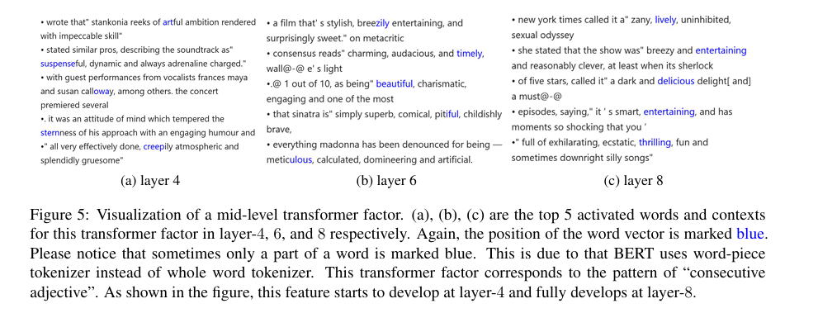
(Yun et al., 2021)
High-level transformer factors correspond to those linguistic patterns that span an extended range in the text (Yun et al., 2021). This paper makes use of LIME to ease the process of identifying the contribution of each token in the sequence. The color reflects the weights w at each position, red means the given position has positive weight and green means negative weight. The magnitude of weight is represented by intensity (Yun et al., 2021).
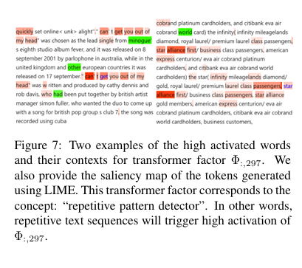
(Yun et al., 2021)

Interpret: The system flow consists of two major stages; offline extraction of the model specific and task specific information such as targets, predictions, relevant hidden states, and attention matrices and running the application itself (Lal et al., 2021). During the offline stage the extracted hidden states are preprocessed using t-SNE before being saved to a file. Interpret has different views to explain the transformer, the views are:
- Attention head summary: InterpreT includes a head summary plot that displays attention head summary statistics for each head and layer (Lal et al., 2021).
- Attention matrix correlation: obtained by computing the correlation between an attention matrix and an arbitrary, same-size matrix (Lal et al., 2021).
- Task-specific attention intensity: a “coreference intensity” metric is devised to pinpoint attention heads with an affinity for identifying coreference relationships (Lal et al., 2021).
- Attention matrix/maps: InterpreT provides the ability to display the attention patterns and weights exhibited by specific attention heads, which can be selected by clicking on a specific head and layer in the head summary plot (Lal et al., 2021).
- Average T-SNE Distance Per Layer: To complement t-SNE visualization of the hidden states, InterpreT also introduces a novel plot showing the average t-SNE space distance between specific groups of terms across all the Transformers’ layers (Lal et al., 2021).
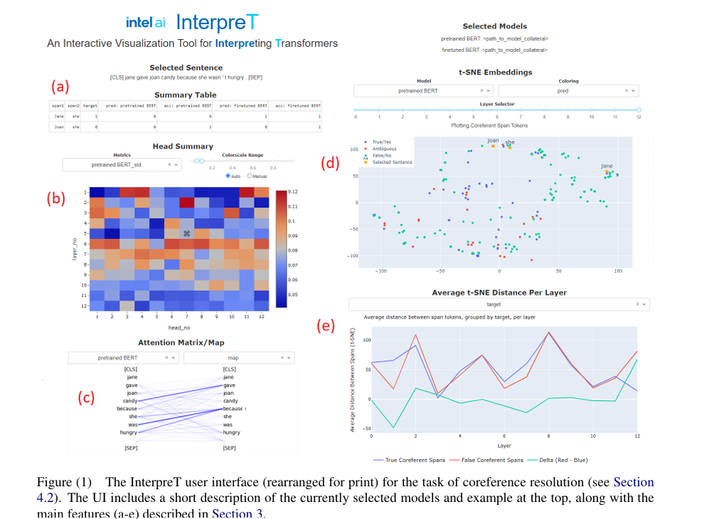
(Lal et al., 2021)
DODRIO: Attention heads are comprised of weights incurred from words when calculating the next representation of the current word, which are known as attention weights. This tool tightly integrates an overview that summarizes the roles of different attention heads, and detailed views. Using attention to understand the model predictions across domains is a very popular research area, due to its ease of interpretation (Wang, Z. J. et al., 2021). DODRIO, explains the transformer in several views, each focusing on the Attention head, semantic and syntactic explanations of the BERT and DistillBERT model.
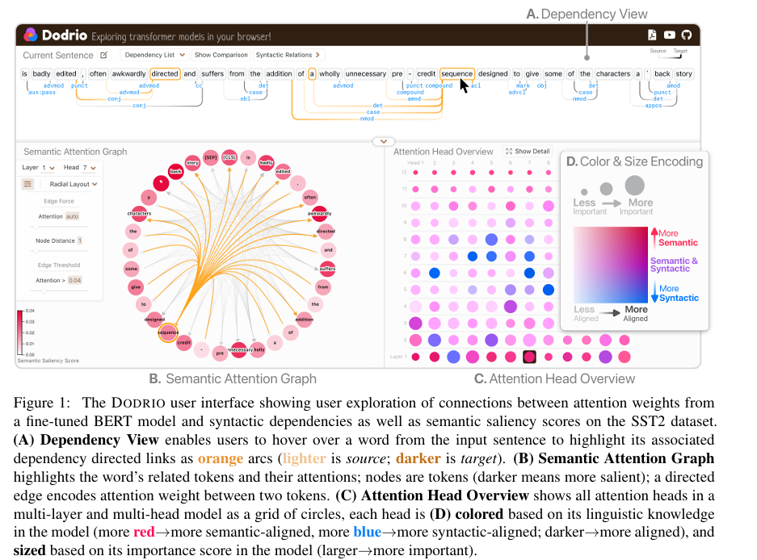
(Wang, Z. J. et al., 2021)
- Attention Head Overview: This view of a grid of attention heads guides the user to inspect semantically and syntactically important heads. The redder, the more semantic-aligned, the bluer, the more syntactic-aligned; darker more aligned (Wang, Z. J. et al., 2021).
- Dependency View (Figure 1A): We visualize true dependency relations, if available, or relations tagged by the CoreNLP pipeline linked with the Semantic Attention Graph for users to investigate syntax-sensitive behavior at different attention heads (Wang, Z. J. et al., 2021).
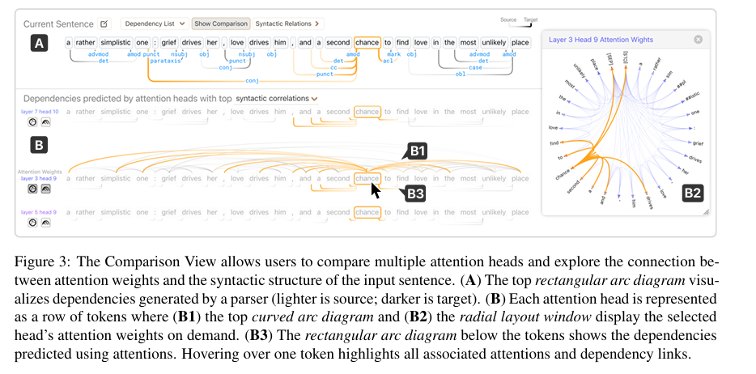
(Wang, Z. J. et al., 2021)
- Comparison View (Figure 3). Understanding raw attention weights are best interpreted relative to the attention weights at other attention heads in the model. The Comparison View enables users to examine the dependencies predicted by attention heads (Figure 3-B3) (Wang, Z. J. et al., 2021).
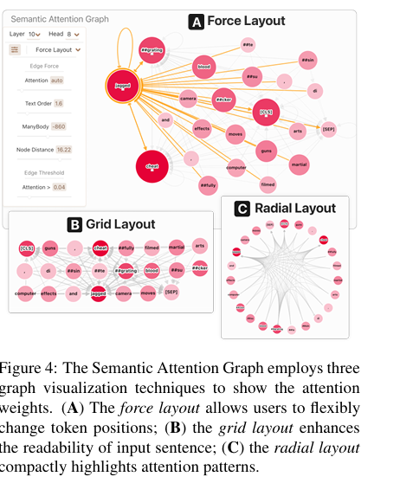
(Wang, Z. J. et al., 2021)
- Semantic Attention Graph: Users can primarily use this interactive graph view to inspect semantically significant attention heads, as defined by the Attention Head Overview. (Wang, Z. J. et al., 2021).
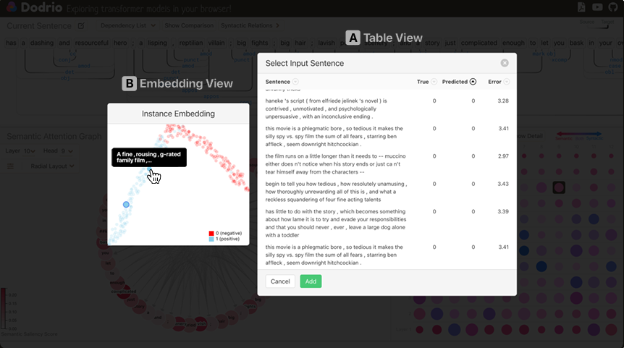
(Wang, Z. J. et al., 2021).
- The Embedding View (Figure S1-A) uses UMAP (McInnes et al., 2018) to project text instance’s model representation computed by concatenating the last four hidden state layers of BERT to a 2D space and visualizes it with a scatter plot(Wang, Z. J. et al., 2021).
- The Table View (Figure S1-B) allows for instance selection while providing the user with instance’s true and predicted labels(Wang, Z. J. et al., 2021).

Real-world application of XAI
AI models have been rapidly improving over the years; they have improved to the point where they are now able to perform certain tasks quickly and more efficiently than humans. Due to this significant improvement, they have now been adopted in several industrial sectors to improve their workflow. The table below contains the industries, sectors, XAI use cases, the primary XAI method used and the VA methods.
Sector | XAI use case | Feature attribution | Feature effects | Saliency / heatmaps | Counterfactuals | Rule extraction | Representation | Primary VA methods
Finance & banking
Credit scoring | Loan approval decisions | ● | ● | — | ● | ● | — | SHAP bar CF table Decision tree
Fraud detection | Anomaly flagging | ● | ○ | — | ○ | ● | ○ | SHAP force Anchors Embedding plot
Algorithmic trading | Strategy transparency | ● | ● | — | — | ○ | ○ | PDP SHAP beeswarm
Risk modelling | Regulatory compliance | ● | ● | — | ● | ● | — | Waterfall ALE CF table
Healthcare & medicine
Clinical diagnosis | Disease prediction | ● | ○ | ● | ● | ● | ○ | Grad-CAM SHAP Decision tree
Medical imaging | Radiology, pathology | ○ | — | ● | ○ | — | ● | Grad-CAM Saliency map Activation max.
Drug discovery | Molecular prediction | ● | ○ | ○ | ● | — | ● | Embedding plot SHAP CF
Treatment planning | Personalised medicine | ● | ● | — | ● | ○ | ○ | CF table ICE plot Waterfall
Legal & criminal justice
Recidivism prediction | Sentencing support | ● | ● | — | ● | ● | — | SHAP bar Anchors CF table
Legal document AI | Contract analysis | ● | — | ● | — | ○ | ○ | Token attribution Attn. heatmap
Autonomous systems & engineering
Self-driving vehicles | Perception decisions | ○ | — | ● | ● | — | ● | Grad-CAM Saliency Decision boundary
Predictive maintenance | Equipment failure | ● | ● | — | ○ | ● | ○ | PDP / ALE SHAP beeswarm Rule extraction
Quality control | Defect detection | ○ | — | ● | ○ | — | ● | Grad-CAM Embedding plot
Natural language processing
Sentiment analysis | Customer feedback | ● | — | ● | ○ | ○ | ● | Token attribution Attn. heatmap LIME
Large language models | Generation transparency | ● | — | ● | ○ | — | ● | Attn. rollout Probing BertSHAP
Content moderation | Harmful content detection | ● | — | ● | ● | ○ | ○ | Token attribution SHAP CF
Human resources & recruitment
CV screening | Candidate shortlisting | ● | ● | — | ● | ● | — | SHAP bar CF table Anchors
Performance prediction | Employee assessment | ● | ● | — | ○ | ○ | — | PDP SHAP beeswarm
E-commerce & marketing
Recommendation systems | Product/content ranking | ● | ○ | — | ● | ○ | ● | SHAP force Embedding plot CF
Churn prediction | Customer retention | ● | ● | — | ● | ● | — | SHAP waterfall ICE CF table
Ad targeting | Audience segmentation | ● | ● | — | ○ | — | ● | PDP Embedding / cluster SHAP
Education & research
Student performance | Learning analytics | ● | ● | — | ● | ○ | — | SHAP bar PDP CF table
Scientific discovery | Model-guided research | ● | ○ | ● | ○ | — | ● | Embedding / UMAP SHAP Saliency

Evaluation of XAI systems
Evaluation metrics are fundamental metrics required to evaluate a particular model. Any assertion that a proposed model is effective without showing the evaluation metrics statis tics is considered hard to accept, because it does not provide any solid proof of the model’s effectiveness to persuade the readers (Minh et al., 2022). XAI Research: Opportunities, challenges, gaps and future research. In the context of XAI, the evaluation metrics enable a thorough measurement of the quality of how well a model meets the XAI requirements. As with the standard evaluation metrics for classification, such as accuracy, precision, and recall, evaluation metrics for XAI should prove the model performance in a specific viewpoint of XAI (Minh et al., 2022). A significant number of authors still use XAI methods as a sort of add-on to their ML models and results without properly addressing the quality aspects of provided explanations, and only a few articles in our corpus use metrics to quantitatively measure the quality of their XAI results (Saarela and Podgorelec, 2024). Before Trust can be placed in in these methods, especially for domain specific applications in real life scenarios, there are some evaluation metrics that need to be hit, has we can not place critical decisions in a system that has not be thoroughly tested and evaluated to meet a standard. We will not go into deep to evaluation in this paper, much of that will be left to future research, but it was important to touch and this area and highlight that there is still no standardized evaluation method for XAI visualization tools.
XAI Research: Challenges, future gaps
1. Evaluation of Explanations Remains Unsolved
Despite hundreds of XAI methods, there is no consensus on how to evaluate whether a visual explanation is actually "good." Most papers use proxy metrics (faithfulness, stability, completeness) without grounding them in real user understanding. We lack standardized, human-centred evaluation frameworks that measure whether visual explanations genuinely improve user decision-making not just perceived trust.
2. The "Explainability Illusion" Problem
Users often feel they understand a model after seeing a visualization but cannot predict model behaviour in new cases. This is sometimes called the illusion of explanatory depth in XAI. Most experiments make use of “frozen models”, users will also benefit from real time explainable visuals, this will provide better understanding of the model. After the use of most XAI tools, users leave feeling like they understand the model, but their understanding cannot be accurately gauged.
3. Lack of Domain-Adaptive Visual Explanations
Most of the XAI visualizations we make use of today were developed by researchers for the purpose of understanding AI systems, these tools were not tailored to be used in specific fields, so it’s makes it difficult to adapt and introduce these tools to specialities in different sectors, with different workflows. For domain-adaptive tools, it’s important to include experts in the field, so visuals, vocabulary and context of the tool can be tailored to the fields needs. Many XAI Most XAI visualizations (saliency maps, feature importance bars, SHAP plots) are generic designed without adapting to domain-specific reasoning workflows (e.g., how a radiologist thinks vs. a financial analyst).
4. Temporal and Sequential Model Explainability
Explaining recurrent models, transformers, and time-series predictions visually is significantly underdeveloped compared to tabular or image-based models, especially for LLMs and forecasting models.

5. Interactivity is Shallow
The explainable AI tools that exist today, have very limited interactions and manipulations of feature space to understand the models behaviour and explanation of its predictions(Alicioglu and Sun, 2022). For model diagnostics, it would be relevant for users to have the ability to remove features one by one until there is a change in prediction, this gives a good understand of how feature affects the prediction. With respect to model performance and performance summary tools such as confusion matrix, which has proved to be insufficient for multiclass classifiers, many studies have developed their own tool specific performance analysis tools, there is a need for generalized tool, which can also save the best configuration of the model to yield required results (Alicioglu and Sun, 2022). Most XAI visual tools are static or pseudo-interactive users can filter or hover but cannot truly interrogate the model.
6. Multi-Modal and High-Dimensional Explanations
As models become multimodal (text + image + tabular), visual explanations struggle to integrate across modalities coherently. Most multimodal explanations are very limited; they seem to explain unimodal aspects of the system separately, but since this model integrate multiple inputs and produce multiple outputs, there is need for unified multimodal explainability, explaining the cross-modal reasoning in a single interface and how they interact with each other.
7. Trust Calibration vs. Trust Induction
Most XAI-VA work tries to build trust. But over trust in AI is equally dangerous. Visual explanations that help users know when not to trust the model are rare. Designing visual analytics for appropriate trust calibration including communicating uncertainty, model limitations, and failure modes is largely unexplored.
8. Scalability to Large-Scale Models
Most real-world applications have high-dimensional datasets, and visualizing this raw data may cause visual clutter. Though we’ve developed methods to enhance visualizing overlapping datapoints, such as colour coding and dimensionality reduction, however in production scale models such as ChatGPT and VIT, there will still be an overlap in the datapoints (Alicioglu and Sun, 2022). Techniques like SHAP and LIME break down in computational and visual terms when applied to large language models or massive tabular datasets.
9. Longitudinal Use of XAI Tools
Almost all XAI-VA studies are short-term lab studies. We know very little about how users interact with explanations over weeks or months. Longitudinal studies examining how mental models evolve, whether users learn to game explanations, or whether explanation fatigue sets in are almost entirely absent.
10. Fairness and Bias Transparency Through Visualization
While fairness in ML is a hot topic, visual tools that make bias and fairness auditing accessible to non-technical stakeholders are still very limited. Bridging fairness metrics with intuitive visual analytics for policymakers, ethicists, and affected communities not just ML engineers is a largely open design space.

Conclusion
This review provides a comprehensive view of the XAI landscape and where the field is headed towards, we have been able to highlight the categories of XAI with visual analytics, exploring the field from its scope, visualization, explainability methods, phases of explainability even down to the limitations of the field and future gaps. Our review serves as the most comprehensive review available now as most other reviews do not explore the existing LLM visualization tool. This review will serve as a great starting point for research as it provides what exists, the methodologies and what is yet to be done, this makes it easier for future researchers to build or prior knowledge.

References
- Angelov, P.P., Soares, E.A., Jiang, R., Arnold, N.I. and Atkinson, P.M. (2021). Explainable artificial intelligence: an analytical review. WIREs Data Mining and Knowledge Discovery, [online] 11(5). doi:https://doi.org/10.1002/widm.1424.
- Cui, W. (2019). Visual Analytics: A Comprehensive Overview. IEEE Access, 7, pp.81555–81573. doi:https://doi.org/10.1109/access.2019.2923736.
- Deussen, O., Ertl, T. and Keim, D. (2010). Visual Analytics. Informatik-Spektrum, 33(6), pp.549–549. doi:https://doi.org/10.1007/s00287-010-0495-6.
- Doran, D., Schulz, S. and Besold, T. (2017). What Does Explainable AI Really Mean? A New Conceptualization of Perspectives. [online] Available at: https://arxiv.org/pdf/1710.00794 [Accessed 1 Mar. 2025].
- Gashi, M., Matej Vuković, Nikolina Jekic, Thalmann, S., Holzinger, A., Jean-Quartier, C. and Fleur Jeanquartier (2022). State-of-the-Art Explainability Methods with Focus on Visual Analytics Showcased by Glioma Classification. BioMedInformatics, 2(1), pp.139–158. doi:https://doi.org/10.3390/biomedinformatics2010009.
- Goebel, R., Chander, A., Holzinger, K., Lecue, F., Akata, Z., Stumpf, S., Kieseberg, P. and Holzinger, A. (2018). Explainable AI: The New 42? Lecture Notes in Computer Science, 11015, pp.295–303. doi:https://doi.org/10.1007/978-3-319-99740-7_21.
- Hoffman, R., Mueller, S., Klein, G. and Litman, J. (2018). Metrics for Explainable AI: Challenges and Prospects Institute for Human and Machine Cognition [rhoffman@ihmc.us]. [online] Available at: https://arxiv.org/pdf/1812.04608 [Accessed 1 Mar. 2025].
- Holzinger, A., Saranti, A., Molnar, C., Biecek, P. and Samek, W. (2022). Explainable AI Methods - A Brief Overview. xxAI - Beyond Explainable AI, pp.13–38. doi:https://doi.org/10.1007/978-3-031-04083-2_2.
- Huang, J. (2024). Explain, Simplify, and Integrate Artificial Intelligence with Visual Analytics. [online] pp.22–24. Available at: https://www.proquest.com/openview/324b51772ae84c1c8f14b7258e294394/1?pq-origsite=gscholar&cbl=18750&diss=y [Accessed 1 Mar. 2025].
- Kucher, K., Zohrevandi, E. and Westin, C.A.L. (2025). Towards Visual Analytics for Explainable AI in Industrial Applications. Analytics, 4(1), p.7. doi:https://doi.org/10.3390/analytics4010007.
- L. Miguel Encarnação, Jörn Kohlhammer and Steed, C.A. (2022). Visualization for AI Explainability. IEEE Computer Graphics and Applications, 42(6), pp.9–10. doi:https://doi.org/10.1109/mcg.2022.3208786.
- Ooge, J., Stiglic, G. and Verbert, K. (2021). Explaining artificial intelligence with visual analytics in healthcare. WIREs Data Mining and Knowledge Discovery, 12(1). doi:https://doi.org/10.1002/widm.1427.
- Radiuk, P., Barmak, O., Manziuk, E. and Krak, I. (2024). Explainable Deep Learning: A Visual Analytics Approach with Transition Matrices. Mathematics, [online] 12(7), p.1024. doi:https://doi.org/10.3390/math12071024.
- Yin, S., Li, H., Sun, Y., Muhammad Ibrar and Teng, L. (2024). Data Visualization Analysis Based on Explainable Artificial Intelligence : A Survey. [online] 2(3), pp.24–31. Available at: https://www.researchgate.net/publication/380362618_Data_Visualization_Analysis_Based_on_Explainable_Artificial_Intelligence_A_Survey [Accessed 1 Mar. 2025].
- Yuan, J., Chen, C., Yang, W., Liu, M., Xia, J. and Liu, S. (2020). A survey of visual analytics techniques for machine learning. Computational Visual Media. doi:https://doi.org/10.1007/s41095-020-0191-7.
- Fischer, M., Simon David Hirsbrunner, Wolfgang Jentner, Miller, M., Keim, D.A. and Helm, P. (2022). Promoting Ethical Awareness in Communication Analysis: Investigating Potentials and Limits of Visual Analytics for Intelligence Applications. ACM Conference on Fairness, Accountability, and Transparency. doi:https://doi.org/10.1145/3531146.3533151
- Wiens, J. and Shenoy, E. (2018). Machine Learning for Healthcare. Clinical Infectious Diseases, [online] 66(1), pp.149–153. Available at: https://www.jstor.org/stable/26525967?searchText=healthcare%20and%20predictive%20machine%20learning&amp;searchUri=%2Faction%2FdoBasicSearch%3FQuery%3Dhealthcare%2Band%2Bpredictive%2Bmachine%2Blearning%26so%3Drel&amp;ab_segments=0%2Fbasic_search_gsv2%2Fcontrol&amp;refreqid=fastly-default%3A1c39e93186d383d5c916ad81ab11d7ba [Accessed 13 Feb. 2025].
- Nithya, B. and Ilango, V. (2017). Predictive analytics in health care using machine learning tools and techniques. 2017 International Conference on Intelligent Computing and Control Systems (ICICCS). Doi:https://doi.org/10.1109/iccons.2017.8250771.
- Xiang, W., Fang, B., Xiang, X., Liu, C., and Zhang, Y. (2021). Predictive modeling of
30-day readmission risk of diabetes patients by logistic regression, artificial neural network, and EasyEnsemble. Asian Pacific Journal of Tropical Medicine, 14(9), p.417. doi:https://doi.org/10.4103/1995-7645.326254.
- Badawy, M. (2023). Healthcare predictive analytics using machine learning and deep learning techniques: a survey. ProQuest, [online] 10(40), p.40. Doi:https://doi.org/10.1186/s43067-023-00108-y.
- Javaid, M., Haleem, A., Singh, R.P., Suman, R. and Rab, S. (2022). Significance of machine learning in healthcare: Features, pillars, and applications. International Journal of Intelligent Networks, [online] 3(2), pp.58–73. doi:https://doi.org/10.1016/j.ijin.2022.05.002.
- Habehh, H. and Gohel, S. (2021). Machine Learning In Healthcare. Current Genomics, [online] 22(4), pp.291–300. doi:https://doi.org/10.2174/1389202922666210705124359.
- Alanazi, A. (2022). Using machine learning for healthcare challenges and opportunities. Informatics in Medicine Unlocked, 30, p.100924. doi:https://doi.org/10.1016/j.imu.2022.100924.
- IBM (2021). Logistic Regression. [online] Ibm.com. Available at: https://www.ibm.com/think/topics/logistic-regression [Accessed 15 Feb. 2025].
- Abdi, H. and Williams, L. J. (2010) Principal Component Analysis. WIREs Computational Statistics, 2 (4) July, pp. 433–459. Available from: <https://doi.org/10.1002/wics.101>.
- Adadi, A. and Berrada, M. (2018) Peeking Inside the Black-Box: A Survey on Explainable Artificial Intelligence (XAI). IEEE Access, 6, pp. 52138–52160. Available from: <https://doi.org/10.1109/ACCESS.2018.2870052>.
- Aken, B. V., Winter, B., Löser, A. and Gers, F. A. (2020) VisBERT: Hidden-State Visualizations for Transformers [Online]. In: Companion Proceedings of the Web Conference 2020, April 20, 2020. Taipei Taiwan: ACM, pp. 207–211. Available from: <https://doi.org/10.1145/3366424.3383542>.
- Alicioglu, G. and Sun, B. (2022) A Survey of Visual Analytics for Explainable Artificial Intelligence Methods. Computers & Graphics, 102 February, pp. 502–520. Available from: <https://doi.org/10.1016/j.cag.2021.09.002>.
- Andrienko, N., Andrienko, G., Adilova, L. and Wrobel, S. (2022) Visual Analytics for Human-Centered Machine Learning. IEEE Computer Graphics and Applications, 42 (1) January, pp. 123–133. Available from: <https://doi.org/10.1109/MCG.2021.3130314>.
- Das, A. and Rad, P. (2020) Opportunities and Challenges in Explainable Artificial Intelligence (XAI): A Survey [Online]. arXiv. Available from: <https://doi.org/10.48550/arXiv.2006.11371>.
- La Rosa, B., Blasilli, G., Bourqui, R., Auber, D., Santucci, G., Capobianco, R., Bertini, E., Giot, R. and Angelini, M. (2023) State of the Art of Visual Analytics for eXplainable Deep Learning. Computer Graphics Forum, 42 (1) February, pp. 319–355. Available from: <https://doi.org/10.1111/cgf.14733>.
- Lal, V., Ma, A., Aflalo, E., Howard, P., Simoes, A., Korat, D., Pereg, O., Singer, G. and Wasserblat, M. (2021) InterpreT: An Interactive Visualization Tool for Interpreting Transformers [Online]. In: Proceedings of the 16th Conference of the European Chapter of the Association for Computational Linguistics: System Demonstrations, 2021. Online: Association for Computational Linguistics, pp. 135–142. Available from: <https://doi.org/10.18653/v1/2021.eacl-demos.17>.
- McInnes, L., Healy, J. and Melville, J. (2020) UMAP: Uniform Manifold Approximation and Projection for Dimension Reduction [Online]. arXiv. Available from: <https://doi.org/10.48550/arXiv.1802.03426>.
- Minh, D., Wang, H. X., Li, Y. F. and Nguyen, T. N. (2022) Explainable Artificial Intelligence: A Comprehensive Review. Artificial Intelligence Review, 55 (5) June, pp. 3503–3568. Available from: <https://doi.org/10.1007/s10462-021-10088-y>.
- Saarela, M. and Podgorelec, V. (2024) Recent Applications of Explainable AI (XAI): A Systematic Literature Review. Applied Sciences, 14 (19) October, p. 8884. Available from: <https://doi.org/10.3390/app14198884>.
- Vig, J. (2019) A Multiscale Visualization of Attention in the Transformer Model [Online]. In: Proceedings of the 57th Annual Meeting of the Association for Computational Linguistics: System Demonstrations, 2019. Florence, Italy: Association for Computational Linguistics, pp. 37–42. Available from: <https://doi.org/10.18653/v1/P19-3007>.
- Wang, Z. J., Turko, R. and Chau, D. H. (2021) Dodrio: Exploring Transformer Models with Interactive Visualization [Online]. arXiv. Available from: <https://doi.org/10.48550/arXiv.2103.14625>.
- Yeh, C., Chen, Y., Wu, A., Chen, C., Viégas, F. and Wattenberg, M. (2023) AttentionViz: A Global View of Transformer Attention. IEEE Transactions on Visualization and Computer Graphics, pp. 1–11. Available from: <https://doi.org/10.1109/TVCG.2023.3327163>.
- Yun, Z., Chen, Y., Olshausen, B. and LeCun, Y. (2021) Transformer Visualization via Dictionary Learning: Contextualized Embedding as a Linear Superposition of Transformer Factors [Online]. In: Proceedings of Deep Learning Inside Out (DeeLIO): The 2nd Workshop on Knowledge Extraction and Integration for Deep Learning Architectures, 2021. Online: Association for Computational Linguistics, pp. 1–10. Available from: <https://doi.org/10.18653/v1/2021.deelio-1.1>.

Appendix
Table 1 — Local Explainability Methods
Model / Technique | ML-based | Data Types | Key Output
Traditional & Statistical Methods
LIME  Local Interpretable Model-agnostic Explanations | No | Tabular, Text, Image | Weighted feature importances for one instance
SHAP (force / waterfall)  SHapley Additive exPlanations – local view | No | Tabular, Text, Image, Time series | Shapley value force / waterfall plot per instance
ICE  Individual Conditional Expectation | No | Tabular | Per-instance prediction curve over a feature range
Counterfactual Explanations  DiCE, DICE-ML, Growing Spheres | No | Tabular, Image | Minimal feature changes to flip the prediction
Anchors  High-precision IF-THEN rules (Ribeiro et al.) | No | Tabular, Text, Image | Rule set that anchors the prediction with high precision
MAPLE  Model Agnostic Supervised Local Explanations | No | Tabular | Local linear model coefficients
Kernel SHAP  Kernel-based SHAP (model-agnostic) | No | Tabular, Text | SHAP values via weighted linear regression
k-NN Similarity  k-Nearest Neighbours example-based | No | Tabular, Image | Ranked list of most similar training instances
Gradient-based & Deep Learning Methods
Grad-CAM  Gradient-weighted Class Activation Mapping | No | Image, Video | Spatial heatmap over discriminative image regions
Grad-CAM++  Improved Grad-CAM (Chattopadhay et al.) | No | Image | Higher-fidelity localisation heatmap
Guided Backpropagation  GuidedBP / DeconvNet | No | Image, Text | Input-space saliency map
Integrated Gradients  IG (Sundararajan et al.) | No | Image, Text, Tabular, Time series | Attribution scores per input pixel / token
SmoothGrad  Noise-averaging gradient saliency | No | Image | Averaged saliency map (noise-reduced)
Layer-wise Relevance Propagation  LRP (Bach et al.) | No | Image, Text, Tabular | Per-neuron / per-pixel relevance score
DeepLIFT  Deep Learning Important FeaTures | No | Image, Tabular, Genomics | Contribution scores relative to a reference activation
RISE  Randomised Input Sampling for Explanation | No | Image | Pixel-level importance map via masked sampling
Attention-based & Transformer XAI — Advanced ML Methods
AttentionViz / BertViz  BertViz (Vig, 2019); AttentionViz (DeRose et al.) | Yes | Text, Time series | Per-head / per-layer attention weight arc diagrams
VisBERT  Visualising BERT Representations (Brunner et al., 2020) | Yes | Text | t-SNE / UMAP geometry of contextual embedding space
Attention Rollout  Rollout (Abnar & Zuidema, 2020) | Yes | Text, Image (ViT) | Propagated attention flow scores across all layers
Transformer Explainability  GradCAM x Attention (Chefer et al., 2021) | Yes | Image, Text | Class-specific relevancy map fused from attention + gradients
ALTI  Aggregated L1-norm Token Influence (Ferrando et al., 2022) | Yes | Text | Token contribution matrix per transformer layer
BertSHAP  Shapley values for transformer token attribution | Yes | Text | Per-token Shapley attribution values for one prediction
Captum (Integrated Gradients on LLMs)  PyTorch attribution library — IG variant | Yes | Text, Tabular | Layer-specific token / neuron attributions
Example-based & Prototype Methods
Influential Training Examples  TracIn / Influence Functions (Koh & Liang, 2017) | Yes | Tabular, Image, Text | Ranked list of most influential training points
TCAV (local variant)  Testing with Concept Activation Vectors – per instance | Yes | Image, Text | Concept sensitivity score for one instance
Counterfactual GAN (C-GAN XAI)  Generative counterfactual explanations | Yes | Image | Synthesised minimal-change counterfactual image

Table 2 — Global Explainability Methods

Model / Technique | ML-based | Data Types | Key Output
Traditional & Statistical Methods
SHAP (summary / beeswarm)  SHapley Additive exPlanations – global view | No | Tabular, Image, Text, Time series | Mean |SHAP| feature importance ranking across dataset
Partial Dependence Plots  PDP (Friedman, 2001) | No | Tabular, Time series | Marginalised average prediction curve per feature
Accumulated Local Effects  ALE (Apley & Zhu, 2020) | No | Tabular | Unbiased main effect curve per feature
Permutation Feature Importance  PFI (Breiman; Fisher et al.) | No | Tabular, Time series | Drop in model metric when feature is shuffled
Global Surrogate Model  Distilled decision tree / linear proxy | No | Tabular, Text, Image, Time series | Interpretable proxy model rules approximating full model
Generalised Additive Models  GAM / Explainable Boosting Machine (EBM) | No | Tabular | Inspectable shape functions per feature
Bayesian Networks  BN / DAG probabilistic graphical models | No | Tabular, Genomics | Directed probabilistic dependency graph
Decision Trees  CART, C4.5, ID3 | No | Tabular | Readable if-then-else rule tree
Feature Attribution & Importance Methods
Random Forest Feature Importance  Gini / MDI importance (Breiman) | No | Tabular | Ranked feature impurity-reduction scores
LASSO Coefficients  L1-regularised linear regression | No | Tabular, Text | Sparse global coefficient vector
Boruta / Recursive Feature Elimination  Wrapper-based feature ranking | No | Tabular, Genomics | All-relevant feature set vs. random shadow features
Activation & Concept-based — Advanced ML Methods
Activation Maximisation  Feature visualisation / Deep Dream | Yes | Image | Synthesised prototype image per neuron or class
TCAV  Testing with Concept Activation Vectors (Kim et al., 2018) | Yes | Image, Text | Concept sensitivity score per layer across a class
Network Dissection  Bau et al. (2017) | Yes | Image | Semantic concept-neuron alignment score (IoU)
Probing Classifiers  Diagnostic / structural probes on frozen representations | Yes | Text (NLP) | Per-layer linguistic / semantic property accuracy
Attention Head Importance Analysis  Michel et al.; Voita et al. (2019) | Yes | Text | Per-head importance and redundancy scores
VisBERT (global)  Visualising BERT layer geometry across full dataset | Yes | Text | Layer-by-layer embedding trajectory for all tokens
Representation & Embedding Analysis Methods
Representational Similarity Analysis  RSA / CKA (Kornblith et al., 2019) | Yes | Image, Text | Layer-to-layer representation similarity matrix
PCA on Hidden Activations  Principal Component Analysis of layer outputs | No | Image, Text, Tabular | Dominant variance-explained directions in latent space
Concept Bottleneck Models  CBM (Koh et al., 2020) | Yes | Image, Tabular | Human-interpretable concept scores + task prediction
Causal & Structural Global Methods
Causal Shapley Values  Causal SHAP (Heskes et al., 2020) | Yes | Tabular | Causally-correct global feature attributions (direct vs. indirect)
Structural Causal Models  SCM / do-calculus (Pearl) | No | Tabular, Simulated | Interventional effect estimates via do-operator
Causal Discovery (PC / GES)  Constraint / score-based causal graph learning | Yes | Tabular, Time series | Inferred causal DAG showing variable relationships

XAI Models Taxonomy

Model / Technique | Phase | Model Agnostic | Data Types Explained | Scope
Pre-modelling Explainability (Ante-hoc / Data-level)
Exploratory Data Analysis  EDA | Pre-modelling | Yes | Tabular, Text, Image, Time series | Global
Correlation Analysis  Pearson / Spearman | Pre-modelling | Yes | Tabular, Time series | Global
Principal Component Analysis  PCA | Pre-modelling | Yes | Tabular, Image, Genomics | Global
t-SNE / UMAP  Dimensionality reduction | Pre-modelling | Yes | Tabular, Image, Text, Omics | Global
Feature Selection  Filter / Wrapper / Embedded | Pre-modelling | Yes | Tabular, Text, Genomics | Global
Interpretable Models (Intrinsic / Glass-box)
Linear / Logistic Regression  GLM | Interpretable model | No | Tabular, Text (TF-IDF) | Global
Decision Tree  CART, C4.5, ID3 | Interpretable model | No | Tabular, Time series | Global
Rule-based / IF-THEN Systems  LAD, Ripper | Interpretable model | No | Tabular | Global
Naive Bayes Classifier  NB | Interpretable model | No | Tabular, Text | Global
k-Nearest Neighbours  k-NN | Interpretable model | No | Tabular, Image | Local
Generalised Additive Models  GAM / EBM | Interpretable model | No | Tabular | Global
Bayesian Networks  BN / DAG | Interpretable model | No | Tabular, Genomics | Global
Attention Mechanisms  Transformers (self-attention) | Interpretable model | No | Text, Image, Time series | Local / Global
Post-hoc Explainability — Model Agnostic
SHAP  SHapley Additive exPlanations | Post-hoc | Yes | Tabular, Image, Text, Time series | Local / Global
LIME  Local Interpretable Model-agnostic Explanations | Post-hoc | Yes | Tabular, Image, Text | Local
Partial Dependence Plots  PDP | Post-hoc | Yes | Tabular, Time series | Global
Individual Conditional Expectation  ICE | Post-hoc | Yes | Tabular | Local
Permutation Feature Importance  PFI | Post-hoc | Yes | Tabular, Time series | Global
Accumulated Local Effects  ALE | Post-hoc | Yes | Tabular | Global
Counterfactual Explanations  DiCE, DICE-ML | Post-hoc | Yes | Tabular, Image | Local
Anchors  High-precision if-then rules | Post-hoc | Yes | Tabular, Text, Image | Local
RISE  Randomised Input Sampling for Explanation | Post-hoc | Yes | Image | Local
Global Surrogate Models  Distilled interpretable proxy | Post-hoc | Yes | Tabular, Text, Image, Time series | Global
Post-hoc Explainability — Model Specific
Grad-CAM  Gradient-weighted Class Activation Mapping | Post-hoc | No | Image, Video | Local
Class Activation Mapping  CAM | Post-hoc | No | Image | Local
Layer-wise Relevance Propagation  LRP | Post-hoc | No | Image, Text, Tabular | Local
Saliency Maps / Integrated Gradients  IG | Post-hoc | No | Image, Text, Time series | Local
Activation Maximisation  Feature visualisation | Post-hoc | No | Image | Global
TCAV  Testing with Concept Activation Vectors | Post-hoc | No | Image, Text | Global
Attention Rollout  Transformer explanation | Post-hoc | No | Text, Image | Local

